**AOI System – Operator Manual**

**Version: 1.1  
Intended Audience: Operators**

Index

Contents

**1. Introduction** 1

**1.1 Purpose of the AOI System** 1

**1.2 Intended Users** 2

**1.4 Operator Responsibilities……………………………………………………………………………………………………** 2

**2 Document Scope And Intended Audience** 4

3**.**2User Roles 5

3.5 System Response 7

**4 Dashboard Screen (Post Login)** 8

4.1. Screen Name 8

5.1 Screen Name 11

**5.7 PLC IO** 13

**5.8 Alarm View** 13

**5.9 Time Sync** 13

**5.11 Operator Access Limitations and Notes** 13

**6 OEE Inspection Dashboard** 14

6.1 Screen Name 14

6.6 Active Batch Information 16

6.7 Live Inspection Feed 16

6.8 Cycle Time Trend (Last 7 Days) 16

6.9 Latest Measurements Panel 16

6.11 Operator Actions 17

6.12 Important Notes for Operator 17

**7**  **Operating Time – Detail View** 18

7.1 Screen Name 18

7.2 Purpose of the Screen 18

7.3 Screen Overview 19

7.4 Displayed Information 19

**7.5 Operating Time** 20

7.6 Operator Actions 20

7.7 Close Action 20

7.8 Important Notes for Operator 20

8.1 Screen Name 21

8.2 Purpose of the Screen 21

8.3 Screen Overview 21

8.4 Displayed Metrics 22

8.5 Operator Actions 22

**9 Avg Cycle (Sec) – Detail View** 24

9.1 Screen Name 24

9.2 Purpose of the Screen 24

9.3 Screen Overview 25

4. Displayed Metrics 25

9.5 Operator Actions 26

9.6 Close Action 26

9.7 Important Notes for Operator 26

10.1 Screen Name 27

10.2 Purpose of the Screen 27

10.3 Screen Overview 27

10.4 Displayed Metric 28

10.5 Operator Actions 28

10.6 Close Action 29

10.7 Important Notes for Operator 29

11.1 Screen Name 30

11.2 Purpose of the Screen 30

11.3 Screen Overview 30

11.4 Displayed Metrics 31

11.5 Operator Actions 32

11.6 Close Action 32

11.7 Important Notes for Operator 32

12.1 Screen Name 33

12.2 Purpose of the Screen 33

12.3 Screen Overview 33

12.4 Displayed Metric 34

12.5 Operator Actions 34

12.6 Close Action 35

12.7 Important Notes for Operator 35

13.1 Screen Name 36

13.2 Purpose of the Screen 36

13.3 Screen Overview 36

13.4 Displayed Metrics 37

13.5 Operator Actions 38

**13.6 Close Action** 38

**13.7 Important Notes for Operator** 38

14.1 Screen Name 39

14.2 Purpose of the Screen 39

14.3 Screen Overview 39

14.4 Displayed Metric 40

**1. OEE Score** 40

14.5 Operator Actions 41

14.6 Close Action 41

14.7 Important Notes for Operator 41

**15.1 Screen Overview** 42

**15.2 Available Operation Modes** 42

**15.3 Auto Run** 42

**15.4 Dry Run** 42

**15.5 Manual** 43

**15.6 Cycle Stop** 43

**15.7 Mass RTO (Return to Origin)** 43

**15.8 Operation Activity Log** 43

**15.9 System Status Indicators** 43

**15.10 Operator Guidelines** 43

**16.1 Screen Overview………………………………………………………………………………………………………………45**

**16.2 System Behavior After Selecting Auto Run** 45

**16.3 Operation Activity Log Update** 45

**16.4 Machine Status Indication** 46

**16.5 Operator Guidelines** 46

**17.2 System Behavior After Selecting Dry Run** 47

**17.3 Operation Activity Log Update** 47

**17.4 Typical Use Cases** 48

**17.5 Operator Guidelines** 48

18.1 Screen Overview 49

18.2 Accessing Manual Operation Screen 49

18.3 Screen Layout Description 49

**18.4 Tray Lift Section** 50

**18.5 Positioning Cylinder Section** 50

**18.6 Transport Conveyor Section** 51

**18.7 Manual X-Axis Jog Section** 51

**18.8 Manual Y-Axis Jog Section** 51

18.11 Operator Notes And Precautions 52

19.1 Screen Overview 53

19.2 Accessing Cycle Stop 53

19.3 Screen Behavior After Cycle Stop 53

19.4 Operation Activity Log Update 54

19.5 Operator Actions After Cycle Stop 54

19.6 Operator Notes And Precautions 54

**19 Machine Home Screen** 55

19.1 Screen Overview 55

19.2 Accessing Machine Home 55

19.3 Screen Behavior After Machine Home Selection 55

19.4 Operation Activity Log Update 56

19.5 Operator Actions During Machine Home 56

**19.6 Operator Actions After Machine Home Completion** 56

**19.7 Operator Notes And Precautions** 56

**20.1 Screen Overview** 58

**20.2 Servo Params Tab – Purpose** 58

**20.3 Servo Params Tab – Screen Layout** 58

**20.4 X-Axis and Y-Axis Parameters** 58

**20.5 Saving Servo Parameters** 59

**20.6 Set Coords Tab – Purpose (Position Teaching)** 59

**20.7 Set Coords Tab – Screen Layout** 59

**20.8 Teaching and Writing Positions** 60

**20.9 Jog and Origin Controls** 60

**20.10 Saving Taught Coordinates** 60

**20.11 Operator Actions** 61

**20.12 Operator Guidelines and Safety Notes** 61

**21.1 Screen Overview** 62

**21.2 Purpose of the Screen** 62

**21.3 Screen Layout Overview** 62

**21.4 Input and Output Tabs** 62

**21.5 Search Function** 63

**21.6 Signal Status Table** 63

**21.7 Status Indication** 63

**21.8 Operator Actions** 63

**21.9 Operator Guidelines and Safety Notes** 63

**22 Alarm View (Active Alarms Screen)** 64

**22.1 Screen Overview** 64

**22.2 Purpose of the Screen** 64

**22.3 Screen Layout Overview** 64

**22.4 Alarm Control Buttons** 65

**22.5 Alarm Records Table** 65

**22.6 Pagination Controls** 65

**22.7 Operator Actions** 65

**22.8 Operator Guidelines and Safety Notes** 66

23.1 Navigation Path 67

23.2 Purpose of Time Sync 67

23.3 Screen Name 67

23.4 Screen Overview 68

23.5 IPC Time Panel 68

**23.6 PLC Time Panel** 68

**23.7 Sync Button (SYNC →)** 69

23.8 Audit Trail Log 69

23.9 Operator Actions 70

**23.10 Operator Limitations** 70

**23.11 Important Notes for Operator** 70

17.1 Navigation Path 71

**24.2 Purpose of Logs** 71

**24.3 Screen Overview** 72

**24.4 Available Log Options** 72

**24.5 Audit Logs** 72

**24.6 Error Logs** 73

**24.7 Diagnostics Logs** 73

**24.8 Operator Limitations** 74

**24.9 Important Notes for Operator** 74

25.1 Screen Name 75

25.2 Purpose of the Screen 75

25.3 Screen Layout Overview 75

25.4 File List Panel 76

25.5 Selecting an Audit Log File 76

25.6 Log Content View 76

25.7 Operator Actions 76

25.8 Operator Limitations 77

25.9 Important Notes for Operator 77

26.1 Screen Name 78

**26.2 Purpose of the Screen** 78

26.3 Navigation Flow 78

26.4 Screen Layout Overview 79

26.5 File List Panel 79

26.6 Selecting an Error Log File 79

26.7 Error Log Content View 80

26.8 Operator Actions 80

26.9 Operator Responsibilities 80

26.10 Operator Limitations 80

26.11 Important Notes for Operator 80

27.1 Screen Name 82

27.2 Purpose of the Screen 82

27.3 Navigation Flow 82

27.4 Screen Layout Overview 83

27.5 File List Panel 83

27.6 Selecting a Diagnostics Log File 83

27.7 Diagnostics Log Content View 84

27.8 Operator Actions 84

27.9 Operator Responsibilities 84

27.10 Operator Limitations 85

27.11 Important Notes for Operator 85

**28.1 Screen Overview** 86

**28.2 Navigation Path** 86

28.3 Screen Layout Description 86

**28.4 Available Report Options** 87

**28.5 Production Data Report** 87

**28.6 Production Images Report** 88

**28.7 Operator Actions** 88

**28.8 Operator Limitations** 88

**28.9 Important Notes for Operator** 88

**29.1 Screen Name** 89

**29.2 Navigation Path** 89

**29.3 Purpose of the Screen** 89

**29.4 Screen Overview** 89

**29.5 Report Selection Panel** 90

**29.6 Report Data Display Area** 91

**29.7 Operator Actions** 91

**29.8 Operator Limitations** 91

**29.9 Important Notes for Operator** 91

**30.1 Screen Name** 92

**30.2 Navigation Path** 92

**30.3 Purpose of the Screen** 92

**30.4 Screen Overview** 93

**30.5 Image Folder Panel** 93

**30.6 Image Display Area** 94

**30.7 Operator Actions** 94

**30.8 Operator Limitations** 94

**30.9 Important Notes for Operator** 94

**31.1 Screen Name** 95

**31.2 Navigation Path** 95

**31.3 Purpose of the Screen** 95

**31.4 Screen Overview** 96

**31.5 Configuration Menu Options** 96

**31.6 Log Config** 97

**31.7 Device Config** 97

**31.8 Alarm Config** 97

**31.9 User Config** 97

**31.10 PLC TAG Config** 98

**31.11 Report Config** 98

**31.12 Diagnostic** 98

**31.13 Operator Notes and Precautions** 99

**32.1 Screen Name** 100

**32.2 Navigation Path** 100

**32.3 Purpose of the Screen** 100

32.2 Accessing Log Configuration 100

**32.4 Screen Overview** 101

**32.5 Table Columns Description** 101

**32.6 Operator Actions** 102

**32.7 Operator Limitations** 102

**32.8 Important Notes for Operator** 102

33.1 Screen Overview 103

33.2 Accessing Device Configuration 103

33.3 Screen Layout Description 104

33.4 Available Operator Actions 104

33.5 Operator Notes And Precautions 105

34.1 Screen Overview 106

34.2 Accessing Alarm Configuration 106

34.3 Screen Layout Description 107

34.4 Alarm List Table Description 107

34.5 Typical Alarm Examples (Operator View) 107

34.6 Operator Actions 107

34.7 Operator Notes And Precautions 108

35.1 Screen Overview 109

35.2 Accessing User Management 109

35.3 Screen Layout Description 109

35.4 User List Table Description 110

35.5 Operator Actions 110

35.6 Operator Notes And Precautions 111

36.1 Screen Overview 112

36.2 Accessing PLC Tag Configuration 112

36.3 Screen Layout Description 112

36.4 PLC Tag Table Description 113

36.5 Typical PLC Tag Usage (Operator View) 113

36.7 Operator Notes And Precautions 114

**37 Report Configuration Screen** 115

**37.1 Screen Name** 115

**37.2 Navigation Path** 115

**37.3 Purpose of the Screen** 115

**37.4 Screen Overview** 116

**37.5 Saved Report Formats Panel** 116

**37.6 Report Details Panel** 116

**37.7 Selected Columns Panel** 117

**37.8 Action Buttons** 117

**37.9 Operator Actions** 117

**37.10 Operator Limitations** 118

**37.11 Important Notes for Operator** 118

**38.1 Screen Name** 119

**38.2 Navigation Path** 119

**38.3 Purpose of the Screen** 119

**38.4 Screen Overview** 120

**38.5 Table Columns Description** 120

**38.6 Search Function** 120

**38.7 Operator Actions** 120

**38.8 Operator Limitations** 120

**38.9 Important Notes for Operator** 120

# **1. Introduction**

The **AOI System (Automated Optical Inspection System)** is an industrial inspection application designed to **automatically monitor, inspect, and evaluate product quality** during the production process.

The system integrates with **machine vision cameras, PLC controllers, and industrial hardware** to perform real-time inspection and collect production data. It helps Operators and Supervisors ensure that every product meets defined quality standards before moving to the next process stage.

The AOI System provides a centralized platform to:

* Monitor inspection performance
* Track production and quality statistics
* Detect and display alarms and system faults
* Maintain system and production logs
* Generate reports for analysis and traceability

This application is primarily intended for **shop-floor Operators** who are responsible for running and monitoring the inspection process.

# **1.1 Purpose of the AOI System**

The main purpose of the AOI System is to:

* Detect product defects automatically using vision-based inspection
* Reduce manual inspection effort and human error
* Improve production efficiency and consistency
* Provide accurate and traceable production records
* Support continuous quality improvement

By using automated inspection, the system ensures **higher accuracy, faster inspection cycles, and reliable quality control** compared to manual method

# **Intended Users**

This Operator Manual is prepared for the following users:

**Operators:**  
Responsible for daily operation, monitoring, and basic control of the AOI System.

* **Supervisors / Quality Staff (View Only):**  
  May use reports and logs for performance analysis and quality tracking.

System configuration and advanced settings are handled by **authorized administrative users** and are not part of routine operator activities.

# **1.3 System Overview**

The AOI System consists of the following main functional areas:

1. **Login and User Authentication**  
   Ensures only authorized users can access the system.
2. **Dashboard and OEE Monitoring**  
   Displays real-time inspection performance, production counts, efficiency, and machine status.
3. **Alarm Monitoring and Logs**  
   Shows system faults, inspection errors, and operational events for troubleshooting and traceability.
4. **Reports and Data Export**  
   Allows Operators to view and export production and quality data in standard formats such as CSV.
5. **Mode of Operation and Manual Control**  
   Provides options for Auto Run, Dry Run, Manual Mode, Cycle Stop, and Machine Homing.
6. **Configuration and External Interface**  
   Enables setup of report formats, devices, alarms, PLC tags, and data interfaces.

# **1.4 Operator Responsibilities**

Operators using the AOI System are expected to:

* Monitor inspection status during production
* Respond to alarms and abnormal conditions
* Follow standard operating procedures during manual operation
* Maintain accurate production records using system logs and reports
* Report system issues to maintenance or administration teams

Proper usage of the AOI System helps ensure **safe, efficient, and high-quality production**.

**2 Document Scope And Intended Audience**

This document is prepared primarily for **Operators** who work on the AOI System in a shop-floor environment.  
The content is written in a clear, practical, and step-by-step manner to support **daily machine operation, monitoring, and reporting activities**.

The explanations strictly follow the **actual system screens, workflow, and operating sequence** used on the production floor.  
All screenshots, labels, and terminology match the live AOI System interface to avoid confusion during operation.

While the system also supports **Administrator-level functions**, this document focuses on **Operator usage only**, except where Admin-related actions are necessary for understanding system behavior.

The objective of this document is to:

* Help Operators quickly understand system usage
* Ensure safe and correct operation of the AOI System
* Maintain consistency between documentation and real-time system behavior

### **Usage Note**

This document should be used as a **reference guide during machine operation**.  
Operators are advised to follow the instructions exactly as described and **avoid performing actions outside their assigned role**.

For configuration changes, system access issues, or abnormal behavior, Operators should always contact the **System Administrator or Maintenance team**.

**3 Login Screen**

**3.1 Purpose**

The **Login Screen** is the first screen displayed when the AOI System application starts.  
It is used to verify the identity of the user and allow secure access to the system.

Only **authorized Operators and Administrators** can log in using valid credentials.

## 3**.**2User Roles

The AOI System supports two types of users:

### **Operator**

* **User Type:** Operator
* Operators use the system for day-to-day machine operation, inspection, monitoring, and report viewing.
* Operators have access only to operational features assigned to their role.

### **Administrator**

* **User Type:** Admin
* Administrators manage system configuration, users, alarms, devices, PLC tags, and reports.
* Admin users have higher-level access compared to Operators.
* Access to system features depends on the logged-in user role.

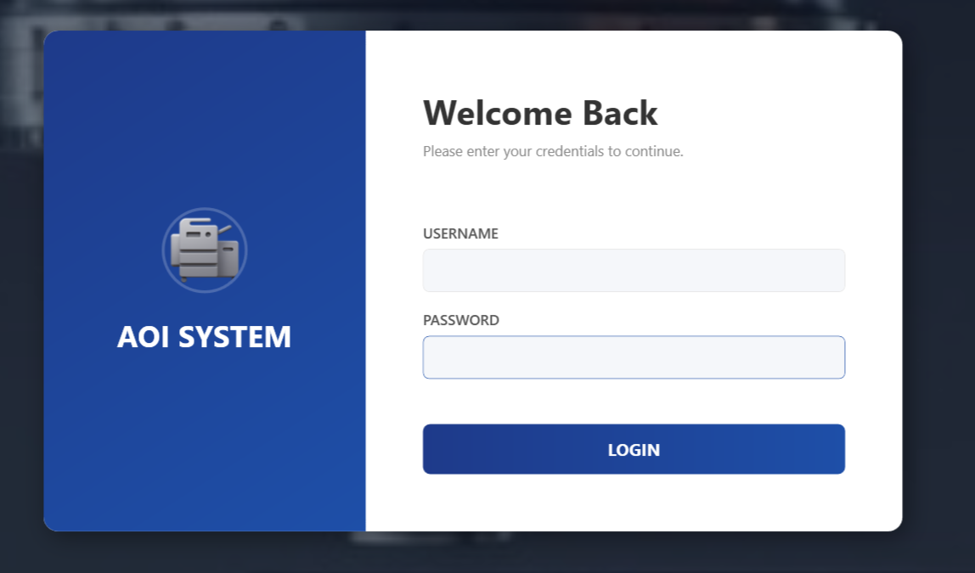

**3.3 Screen Overview**

The **Login Screen** includes the following items:

### **System Name**

* Displays the application name **AOI System**.

### **Username Field**

* Used to enter the assigned username for the Operator or Administrator.

### **Password Field**

* Used to enter the corresponding password.
* The password is masked for security purposes.

### **Login Button**

* Used to submit login credentials and access the system.

**3.4 Login Steps**

To log in, follow these steps:

1. Open the **AOI System** application.
2. Enter the username in the **Username** field.
3. Enter the password in the **Password** field.
4. Click the **Login** button.
5. If the credentials are correct:
   * Operators are redirected to the **Operator Dashboard**.
   * Administrators are redirected to the **Admin Dashboard**.

## 3.5 System Response

### **Successful Login**

* The system validates the credentials.
* Access is granted based on the user role.
* The appropriate dashboard is displayed.
* Authorized features become available.

Login Failure

If the username or password is incorrect:

* An error message is displayed.
* Access is denied.
* The user must re-enter correct credentials.

**3.6 Security Guidelines**

Username is **case-insensitive**.

Password is **case-sensitive**.

Users must keep login credentials confidential.

Multiple incorrect login attempts may temporarily block access.

For login-related issues, contact the **System Administrator**.

**3.7 User Responsibility**

**Operator Responsibility**

* Do not share login credentials.
* Log out after completing work.
* Report any access issues to the administrator.

### **Administrator Responsibilities**

* Manage user accounts responsibly.
* Ensure only authorized users have access.
* Monitor login issues and resolve access problems.

### **4 Dashboard Screen (Post Login)**

## 4.1. Screen Name

**Operator Dashboard / Home Screen**

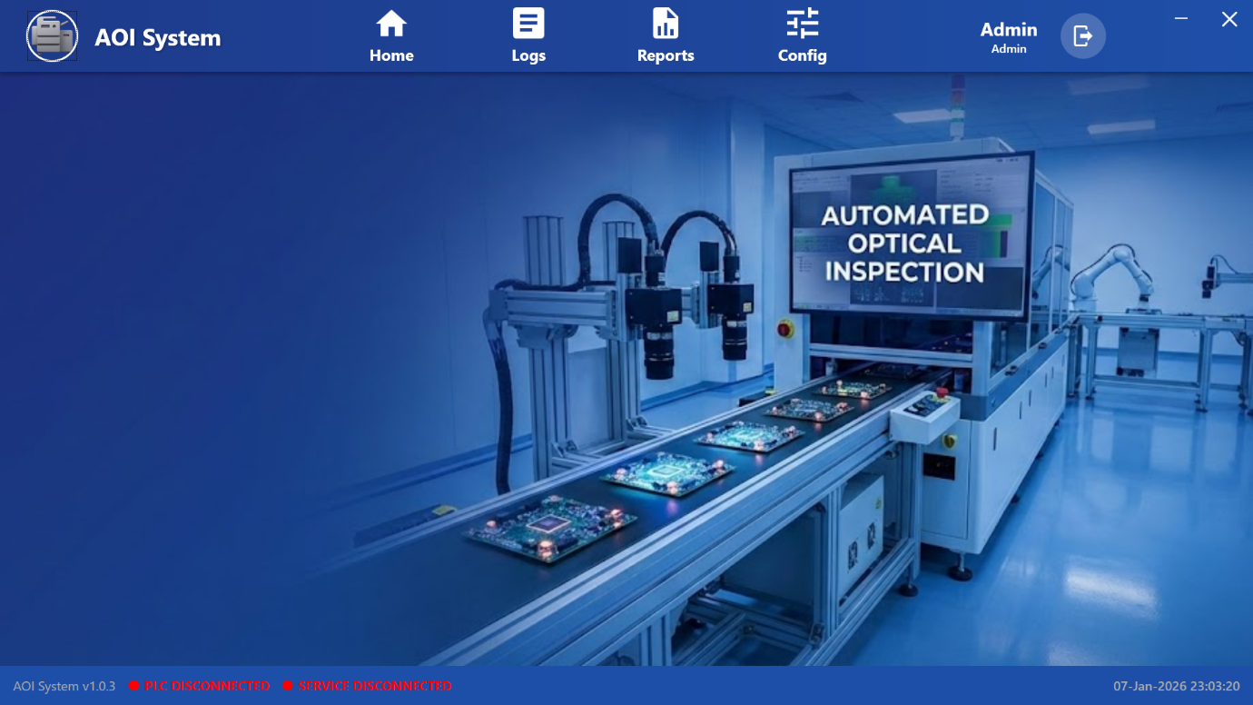

**4.2 Purpose of the Screen**

The Dashboard Screen is displayed after a successful login.  
It is the primary working screen for the Operator to monitor machine status and access major system functions.

From this screen, the Operator can:  
• Monitor system connectivity  
• Access Logs and Reports  
• Navigate to configuration options (as per permission)  
• Check system alerts and status messages

**4.3 Screen Overview**

The Dashboard screen is divided into the following main sections:  
• Top Navigation Bar  
• Main Display Area  
• Bottom Status Bar

Each section provides important operational and system information to the Operator.

**4.4 Top Navigation Bar**

The top navigation bar is located at the top of the screen and provides quick access to major modules of the AOI System.

Available options include:

* **Home**  
  Returns to the main dashboard view.
* **Logs**  
  Used to view system and operation logs.
* **Reports**  
  Used to view inspection and performance reports.
* **Config**  
  Used for configuration-related options (access depends on permission).
* **User Info / Logout**  
  Displays the logged-in user and provides logout option.

**4.5 Main Display Area**

The central area of the Dashboard displays a visual representation of the AOI machine working environment.

This display shows:  
• Automated Optical Inspection machine setup  
• Conveyor system with boards under inspection  
• Camera inspection stations  
• Overall operational condition of the machine

This visual helps the Operator quickly confirm that the system is running and inspection is in progress.

**4.6 System Status Information**

The bottom status bar displays real-time system information and alerts.

Typical status indicators include:

• **System Version**  
Displays the current software version of the AOI system (e.g., AOI System v1.0.3).

• **PLC Connection Status**  
Shows whether the PLC is connected or disconnected.

• **Service Connection Status**  
Indicates whether background services are connected or disconnected.

• **Date and Time**  
Displays the current system date and time for operational reference.

These indicators help the Operator quickly identify system health and connectivity issues.

**4.7 Operator Actions from Dashboard**

From the Dashboard screen, the Operator can:  
• Monitor PLC and service connectivity  
• Navigate to Logs for troubleshooting  
• Open Reports to review inspection results  
• Observe machine operational status  
• Log out after completing shift or task

**4.8 Operator Limitations**

• Operators cannot modify critical system configuration parameters.  
• Advanced configuration options are restricted to Admin users.  
• Access to Config module depends on assigned user permissions.  
• Operators are allowed only to view data and perform permitted actions.

**5 Dashboard – Menu View**

## 5.1 Screen Name

**Dashboard – Menu Screen**

**5.2 Purpose of the Screen**

This screen is displayed when the Operator is on the Dashboard and the left-side menu is visible.  
It provides quick access to important operational and monitoring functions of the AOI system.

This screen allows the Operator to:  
• Monitor machine operation  
• Check servo and PLC I/O status  
• View alarms  
• Synchronize system time  
• Navigate between operational modules

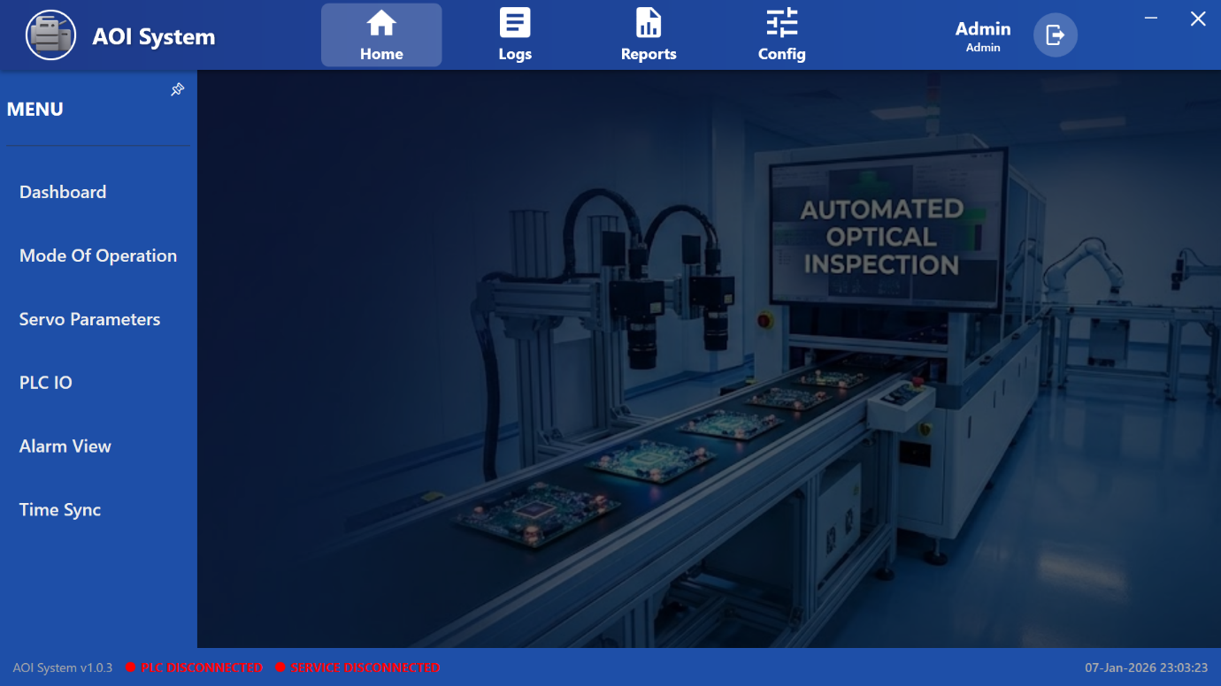

**5.3 Screen Layout Overview**

The screen is divided into two main sections:  
• Left Menu Panel  
• Main Display Area

**5.4 Left Menu Panel (Operator View)**

The left-side menu provides navigation to important Operator functions.

Available menu options include:

• **Dashboard**  
Returns to the main dashboard visual showing the AOI machine working environment.

• **Mode of Operation**  
Used to select or view the current operating mode of the machine such as Auto Run or Dry Run.

• **Servo Parameters**  
Used to view servo-related parameters and motion status of machine axes.  
(Editing access depends on user permission.)

• **PLC IO**  
Displays real-time PLC input and output status for monitoring machine signals and sensors.

• **Alarm View**  
Used to view active and historical alarms generated by the system.

• **Time Sync**  
Used to synchronize system time to ensure correct timestamps in logs and reports.

**5.5 Mode of Operation**

### • Displays the current machine operation mode. • Allows switching between modes such as Auto Run and Dry Run (as permitted). • Helps ensure the machine is running in the correct operating condition.

**5.6 Servo Parameters**

• Displays servo motor status and related parameters.  
• Used to monitor axis position, movement, and servo health.  
• Helps in identifying motion-related issues.

### **5.7 PLC IO**

• Displays real-time PLC input and output signals.  
• Helps verify sensor status and actuator responses.  
• Useful for troubleshooting machine interlocks and signal flow.

### **5.8 Alarm View**

• Displays active alarms and alarm history.  
• Provides information about faults and abnormal conditions.  
• Helps the Operator take corrective actions or inform maintenance.

### **5.9 Time Sync**

• Used to synchronize system date and time.  
• Ensures accurate timestamps for logs, reports, and alarms.  
• Recommended to verify time before starting production.

**5.10 Operator Actions**

From this screen, the Operator can  
• Navigate to different operational modules  
• Check current operating mode  
• Monitor servo and PLC signal status  
• View alarms and system warnings  
• Synchronize system time when required

### **5.11 Operator Access Limitations and Notes**

• Operators can view system data but cannot modify critical parameters.  
• Advanced configuration settings are restricted to Admin users.  
• Access to certain options depends on assigned permissions.  
• Operators should immediately report repeated alarms to the supervisor or maintenance team.

### **6 OEE Inspection Dashboard**

## 6.1 Screen Name

**OEE Inspection Dashboard**

**6.2. Purpose of the Screen**

The OEE Inspection Dashboard is used to monitor machine performance and inspection status in real time.  
It provides key operational metrics required by the Operator during daily production.

This screen helps the Operator understand:  
• Machine operating and downtime status  
• Inspection cycle performance  
• Quality results and output count  
• Current batch and inspection activity

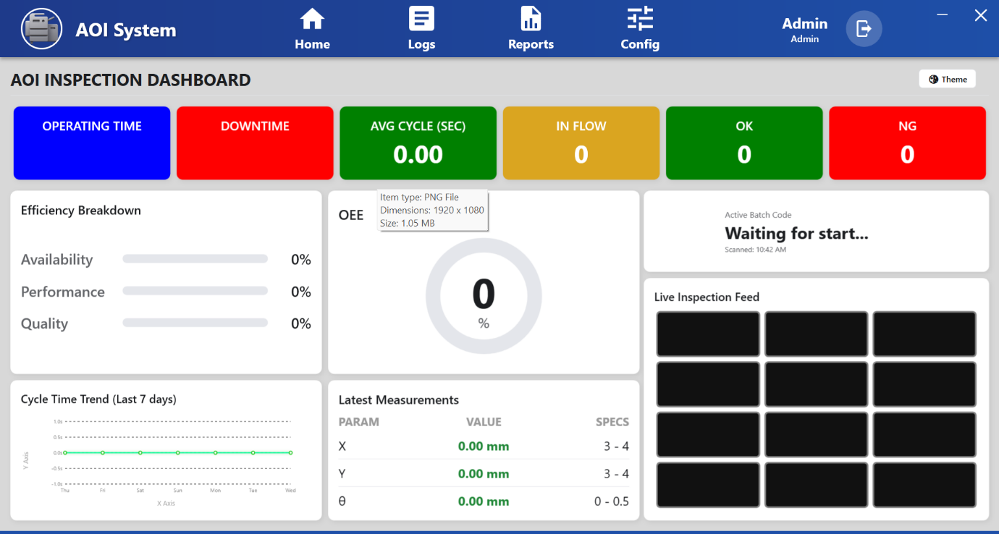

**6.3 Top Performance Indicators**

The top section displays key performance values in colored tiles:

• **Operating Time**  
Shows the total time the machine has been running.

• **Downtime**  
Shows the total time the machine was stopped or idle.

• **Avg Cycle (Sec)**  
Displays the average inspection cycle time in seconds.

• **In Flow**  
Shows the number of boards/components currently under inspection.

• **OK**  
Displays the count of passed inspections.

• **NG**  
Displays the count of failed inspections.

**6.4 Efficiency Breakdown Panel**

This section shows efficiency details in percentage using progress bars:

• **Availability**  
Indicates how much time the machine was available for operation.

• **Performance**  
Indicates how efficiently the machine is running compared to the expected speed.

• **Quality**  
Indicates the percentage of good (OK) inspection results.

**6.5 OEE Indicator**

## **• Displays the Overall Equipment Effectiveness (OEE) value in percentage using a circular gauge. • Combines Availability, Performance, and Quality into a single metric. • Helps the Operator quickly assess overall system efficiency.**

## 6.6 Active Batch Information

## **• Displays the current batch status. • Example: “Waiting for start…” indicates inspection has not yet started. • Shows the last scanned time of the batch.**

## 6.7 Live Inspection Feed

## **• Displays live camera frames from the inspection stations. • Multiple camera views are shown in grid format. • Black or empty frames indicate that inspection is not currently active or cameras are idle.**

## 6.8 Cycle Time Trend (Last 7 Days)

## **• Shows a graphical trend of inspection cycle time over the last seven days. • Helps identify performance stability or variations. • Useful for monitoring long-term consistency.**

## 6.9 Latest Measurements Panel

Displays the most recent measurement values in tabular format:

• **Parameter Name** (e.g., X, Y, θ)  
• **Measured Value** (in mm or defined unit)  
• **Specification Range**

Helps the Operator verify whether measurements are within acceptable limits.

**6.10 System Status Information**

At the bottom of the screen, the following information is displayed:

• System Version (e.g., AOI System v1.0.3)  
• PLC Connection Status  
– Example: **PLC Disconnected**  
• Service Connection Status  
– Example: **Service Disconnected**  
• Current Date and Time

## 6.11 Operator Actions

## **From the OEE Inspection Dashboard, the Operator can: • Monitor inspection performance in real time • Track OK and NG counts • Observe live camera feeds • Identify downtime or connectivity issues • Inform supervisor in case of abnormal values**

## 6.12 Important Notes for Operator

• Always verify PLC and Service connection status before starting inspection.  
• If OEE and efficiency values remain zero, check whether inspection has started.  
• Black camera screens indicate no active inspection or camera idle state.  
• Report repeated NG results or abnormal measurements immediately.

### **7** **Operating Time – Detail View**

## 7.1 Screen Name

**Operating Time – Detail View**

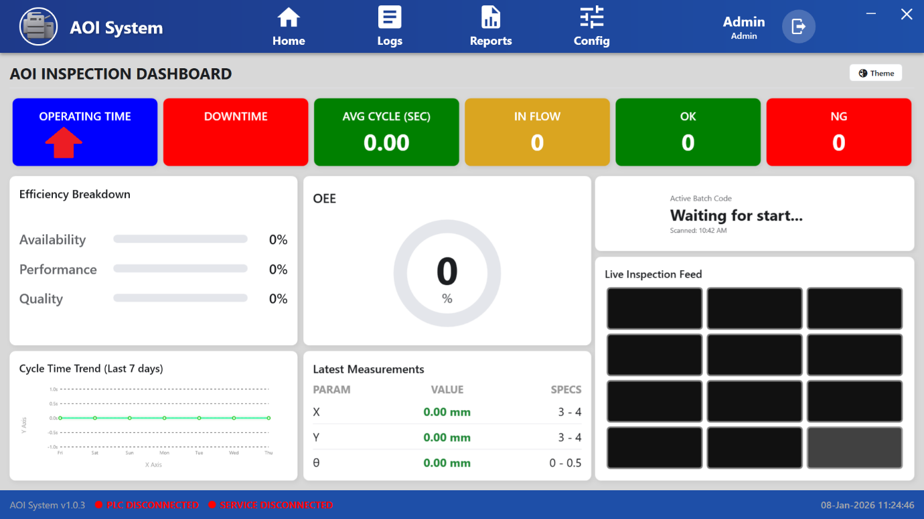

## 7.2 Purpose of the Screen

The Operating Time screen displays the machine running time summary for different time periods.  
It helps the Operator understand how long the system has been operating today, during the current week, and during the current month.

This screen is used only for monitoring and review purposes.

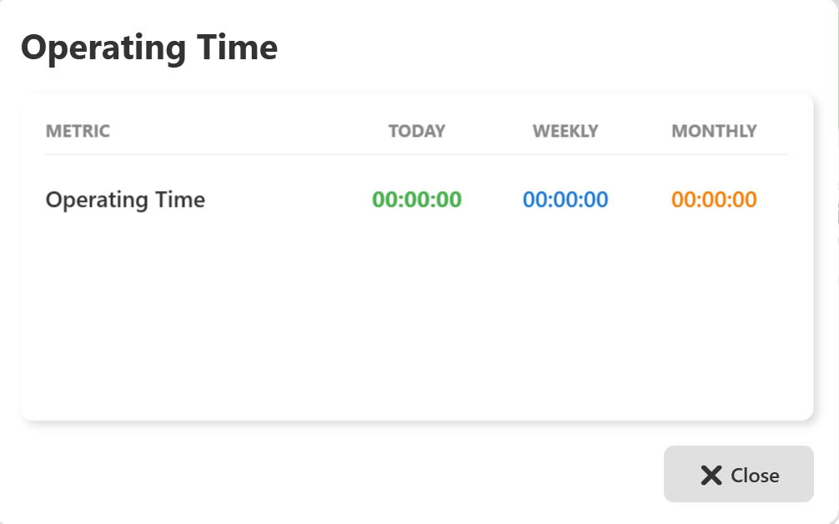

## 7.3 Screen Overview

## **The screen displays operating time data in a simple tabular format with the following columns: • Metric • Today • Weekly • Monthly**

## **Only one main metric,** **Operating Time**, **is displayed in this screen.**

## 7.4 Displayed Information

This screen shows the operating duration in **HH:MM:SS (Hours:Minutes:Seconds)** format for each time period.

Displayed values are color coded:  
• Today – shown in green  
• Weekly – shown in blue  
• Monthly – shown in orange

This helps the Operator easily differentiate between time periods.

### **7.5 Operating Time**

• **Today**  
Shows the total operating time of the machine for the current day.

• **Weekly**  
Shows the total operating time of the machine for the current week.

• **Monthly**  
Shows the total operating time of the machine for the current month.

If the values are displayed as **00:00:00**, it indicates that:  
• The machine has not started operation yet, or  
• No operating data is available for the selected time period.

## 7.6 Operator Actions

From this screen, the Operator can:  
• View operating time statistics  
• Compare today, weekly, and monthly operating durations  
• Close the screen after reviewing the data

There are no control or editing functions available on this screen.

## 7.7 Close Action

## • Click the **Close (X)** button at the bottom-right of the screen to exit the Operating Time view. • The system will return to the previous Dashboard or OEE screen.

## 7.8 Important Notes for Operator

• Operating Time values are updated automatically based on machine activity.  
• If values remain **00:00:00** during production, check:  
o Machine running status  
o PLC and Service connection status  
• Report data display issues to the system administrator or maintenance team.

**8 Downtime Statistics – Detail View**

## 8.1 Screen Name

**Downtime Statistics – Detail View**

## 8.2 Purpose of the Screen

The Downtime Statistics screen displays the total machine stoppage time for different time periods.  
It helps the Operator understand how long the machine was stopped today, during the current week, and during the current month.  
This screen is used only for monitoring and review purposes.

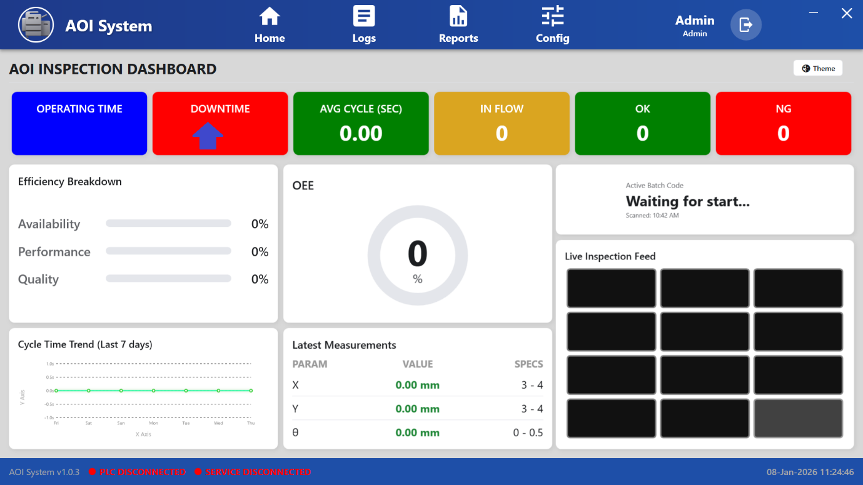

## 8.3 Screen Overview

The screen displays downtime data in a simple tabular format with the following columns:  
• Metric  
• Today  
• Weekly  
• Monthly

Only one main metric, **Total Stop**, is displayed on this screen.

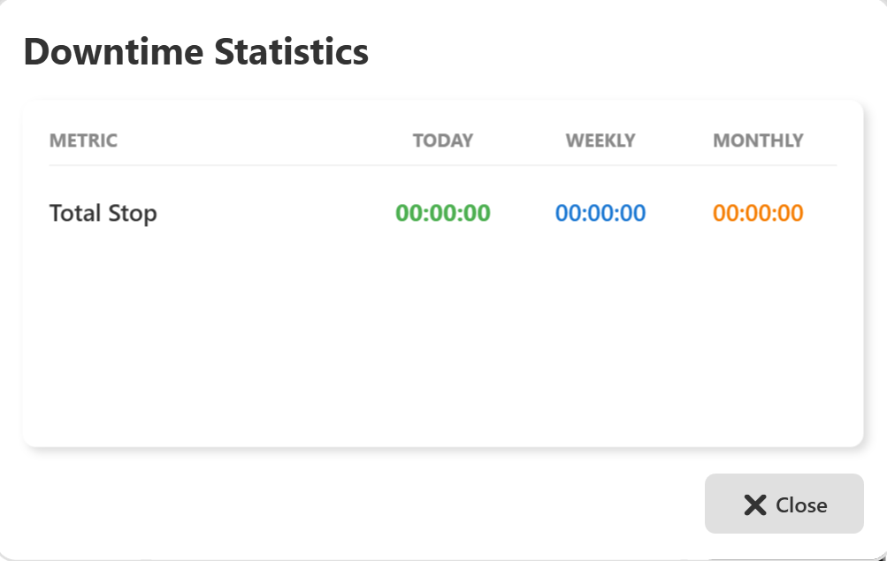

## 8.4 Displayed Metrics

### **Total Stop** • Shows the total duration of machine stoppage in **HH:MM:SS (Hours:Minutes:Seconds)** format. • Displays downtime for Today, Weekly, and Monthly periods.

Displayed values are color coded:  
• Today – shown in green  
• Weekly – shown in blue  
• Monthly – shown in orange

If the values are displayed as **00:00:00**, it indicates that:  
• No machine stoppage has occurred, or  
• No downtime data is available for the selected time period.

## 8.5 Operator Actions

From this screen, the Operator can:  
• Review total downtime duration  
• Compare Today, Weekly, and Monthly stoppage time  
• Close the screen after reviewing the data

No changes or inputs are allowed on this screen.

## 8.6 Close Action

## • Click the **Close (X)** button at the bottom-right of the screen to exit the Downtime Statistics view. • The system will return to the previous Dashboard or OEE screen.

## 8.7 Important Notes for Operator

• Downtime values are recorded automatically by the system based on machine status.  
• If downtime remains **00:00:00** during production, check:  
o Machine running status  
o PLC and Service connection status  
• Repeated or long stoppages should be reported to the supervisor or maintenance team.

### **9 Avg Cycle (Sec) – Detail View**

## 9.1 Screen Name

**Avg Cycle (Sec)**

(Same as displayed in the application UI)

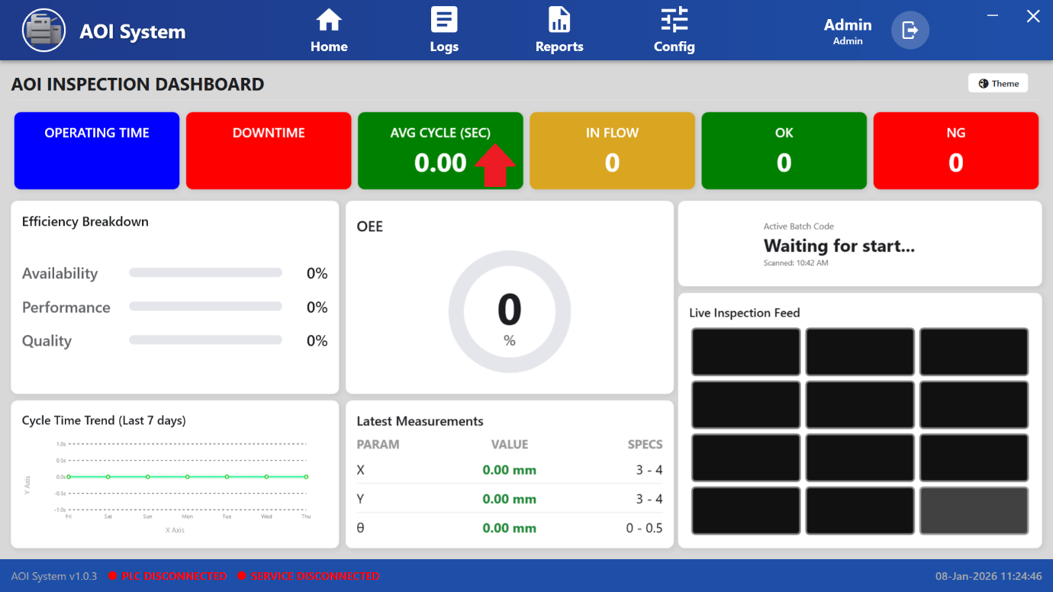

## 9.2 Purpose of the Screen

The **Avg Cycle (Sec)** screen shows the **average inspection cycle time** of the system.  
It helps the Operator understand how much time the machine takes to inspect one board or component.

This screen is used only for **monitoring and performance review**.

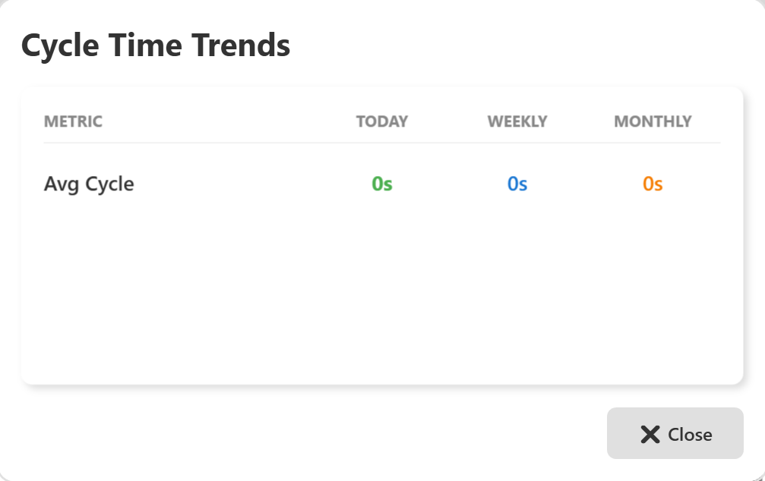

## 9.3 Screen Overview

The screen displays cycle time data in a simple tabular format with the following columns:  
• Metric  
• Today  
• Weekly  
• Monthly

Only one main metric, **Avg Cycle**, is displayed on this screen.  
All values are displayed in **seconds (s)**.

## 4. Displayed Metrics

### **Avg Cycle** • Shows the average inspection cycle time in seconds. • Displays values for Today, Weekly, and Monthly periods.

Displayed values are color coded:  
• Today – shown in green  
• Weekly – shown in blue  
• Monthly – shown in orange

If the values are displayed as **0s**, it indicates that:  
• Inspection has not started yet, or  
• No cycle time data is available for the selected time period.

## 9.5 Operator Actions

From this screen, the Operator can:  
• View average cycle time values  
• Compare Today, Weekly, and Monthly cycle times  
• Close the screen after reviewing the data

No input, control, or configuration actions are available on this screen.

## 9.6 Close Action

## • Click the **Close (X)** button at the bottom-right of the screen to exit the Avg Cycle (Sec) view. • The system will return to the previous OEE Dashboard screen.

## 9.7 Important Notes for Operator

• Lower and stable cycle time indicates better machine performance.  
• Sudden increase in cycle time may indicate mechanical or process issues.  
• If values remain **0s** during production, check:  
o Machine running status  
o PLC and Service connection status  
• Report abnormal cycle time trends to the supervisor or maintenance team.

**10 Input Statistics**

## 10.1 Screen Name

**Input Statistics**

(Opened when Operator clicks on ***In Flow***)

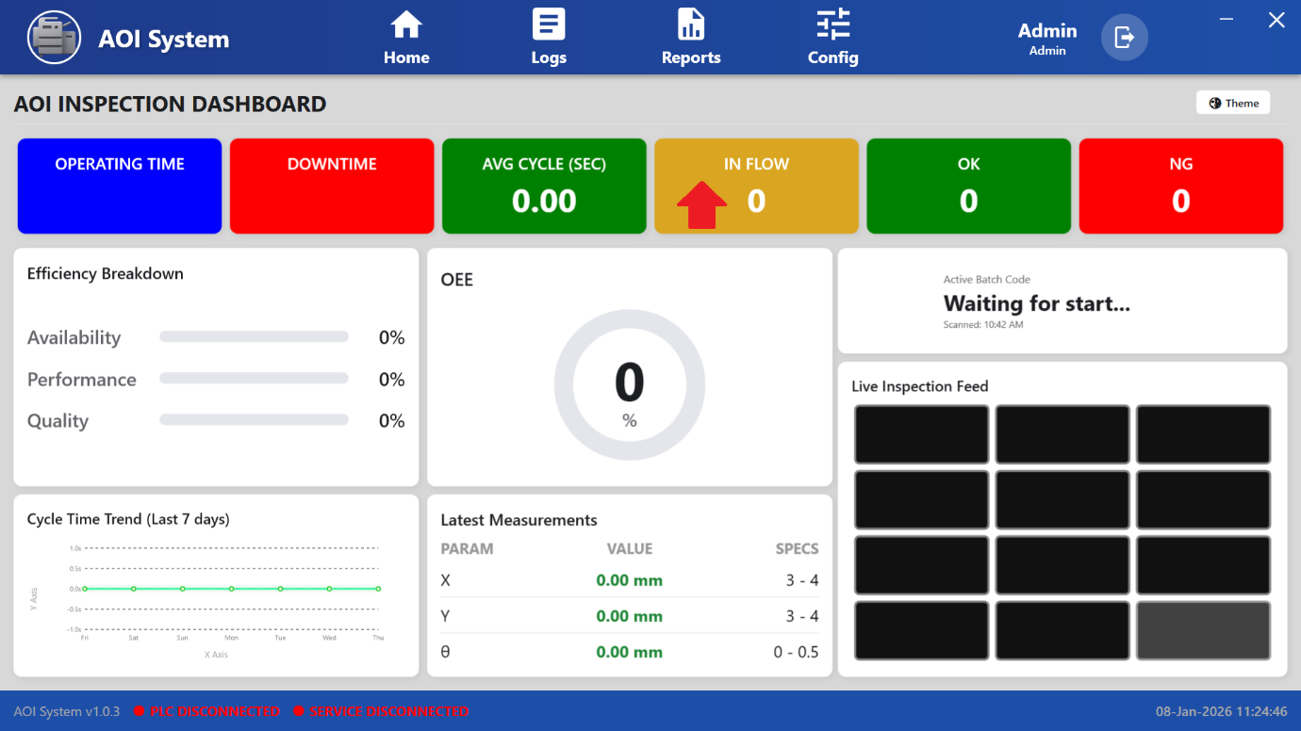

## 10.2 Purpose of the Screen

## The Input Statistics screen displays the total number of inputs received by the AOI system. It helps the Operator understand how many boards or components have entered the inspection process during different time periods. This screen is used only for monitoring production input.

## 10.3 Screen Overview

The screen displays input data in a simple tabular format with the following columns:  
• Metric  
• Today  
• Weekly  
• Monthly

Only one main metric, **Total Input**, is displayed on this screen.

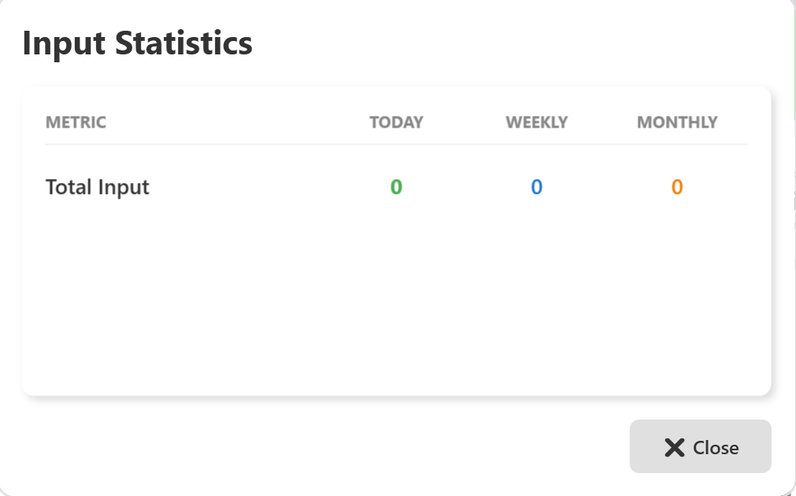

## 10.4 Displayed Metric

### **1. Total Input** • Shows the total number of boards/components received by the system. • Displays count values for: o Current Day (Today) o Current Week (Weekly) o Current Month (Monthly)

## **Displayed values are color coded:** • Today – shown in green • Weekly – shown in blue • Monthly – shown in orange

## If the value is displayed as **0**, it indicates that: • No board/component has entered the system yet, or • Inspection has not started, or • No input data is available for the selected time period.

## 10.5 Operator Actions

From this screen, the Operator can:  
• View total input count  
• Compare Today, Weekly, and Monthly input values  
• Close the screen after reviewing information

No editing, control, or configuration actions are available on this screen.

## 10.6 Close Action

• Click the **Close (X)** button at the bottom-right of the screen to exit the Input Statistics view.  
• The system will return to the previous OEE Dashboard screen.

## 10.7 Important Notes for Operator

• Input count updates automatically when boards enter the inspection conveyor.  
• If input remains **0** during production, check:  
o Machine running status  
o PLC and Service connection status  
• Report any data mismatch or abnormal behavior to the supervisor or system administrator.

**11 Production Quality (OK)**

## 11.1 Screen Name

**Production Quality (OK)**

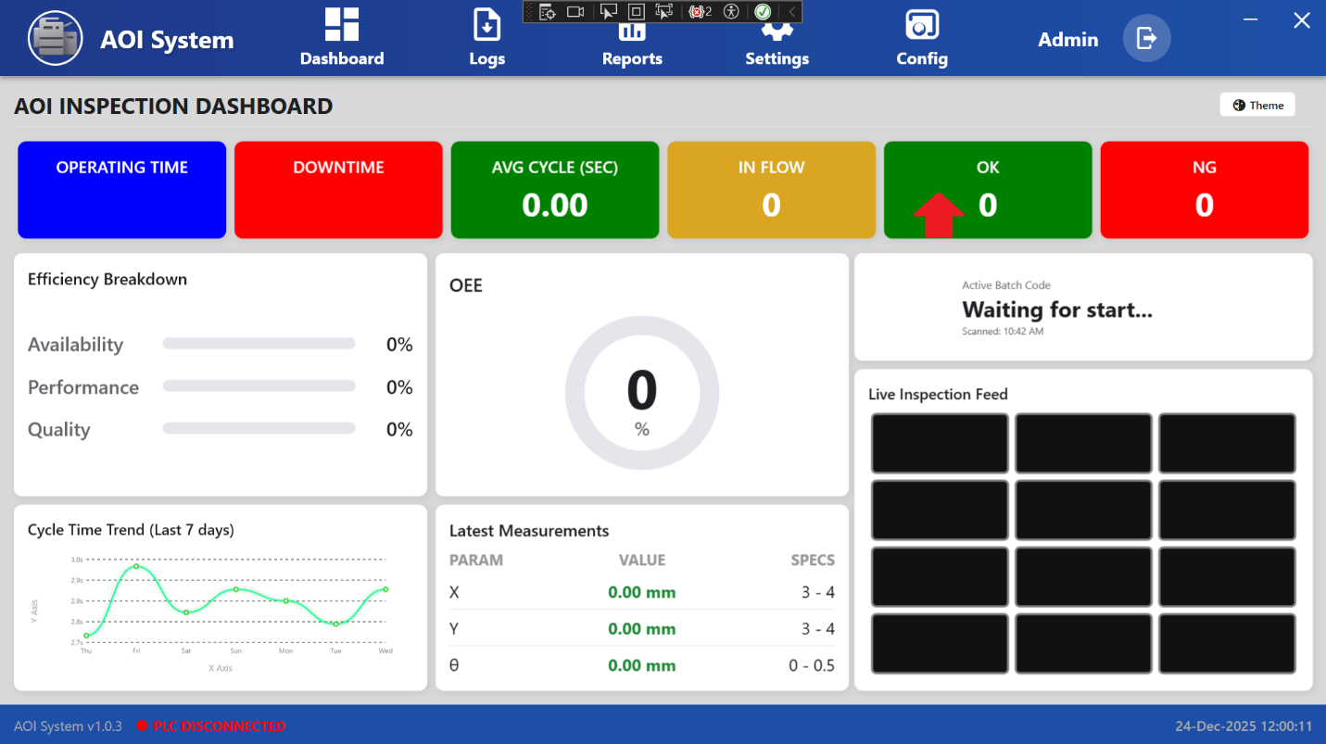

## 11.2 Purpose of the Screen

## The Production Quality (OK) screen displays the total number of good units that have passed inspection. It helps the Operator monitor accepted production output for different time periods. This screen is used only for quality monitoring and production review.

## 11.3 Screen Overview

The screen displays quality data in a simple tabular format with the following columns:  
• Metric  
• Today  
• Weekly  
• Monthly

Only one main metric, **Good Units**, is displayed on this screen.

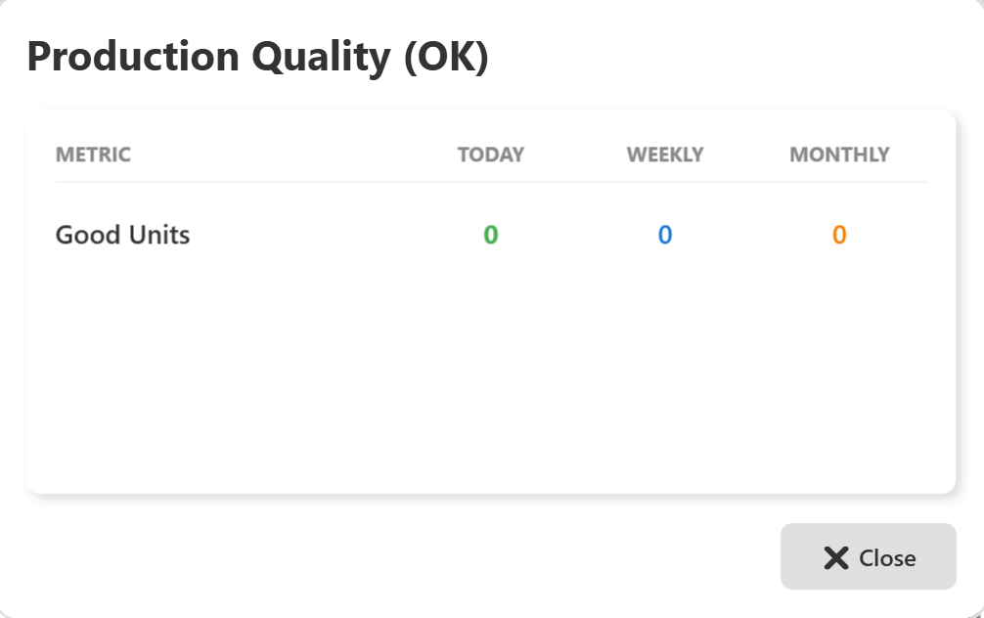

## 11.4 Displayed Metrics

### **Good Units**

### • Shows the total number of units that have passed inspection (OK). • Displays count values for: o Current Day (Today) o Current Week (Weekly) o Current Month (Monthly)

Displayed values are color coded:  
• Today – shown in green  
• Weekly – shown in blue  
• Monthly – shown in orange

If the value is displayed as **0**, it indicates that:  
• Inspection has not started, or  
• No unit has passed inspection yet, or  
• No quality data is available for the selected time period.

## 11.5 Operator Actions

From this screen, the Operator can:  
• View total good unit count  
• Compare Today, Weekly, and Monthly OK values  
• Close the screen after reviewing the data

No editing, control, or configuration actions are available on this screen.

## 11.6 Close Action

## • Click the **Close (X)** button at the bottom-right of the screen to exit the Production Quality (OK) view. • The system will return to the previous OEE Dashboard screen.

## 11.7 Important Notes for Operator

• OK count increases automatically when units pass inspection.  
• If OK count remains **0** during production, check:  
o Whether inspection has started  
o Machine and PLC connection status  
• If OK count is lower than expected, inform the supervisor or quality team for further investigation.

**12 Rejection Statistics (NG)**

## 12.1 Screen Name

**Rejection Statistics (NG)**

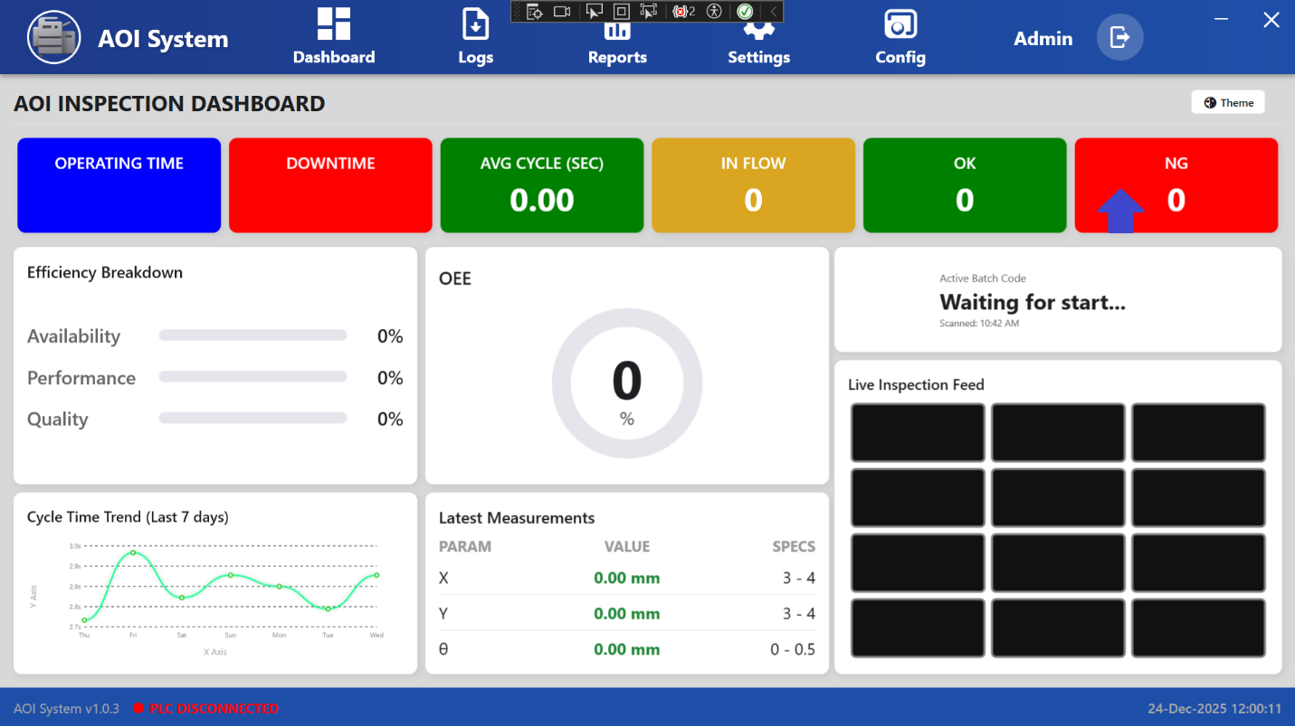

## 12.2 Purpose of the Screen

## The Rejection Statistics (NG) screen displays the total number of units that failed inspection. It helps the Operator monitor rejected output for different time periods and identify quality issues. This screen is used only for quality monitoring and review purposes.

## 12.3 Screen Overview

The screen displays rejection data in a simple tabular format with the following columns:  
• Metric  
• Today  
• Weekly  
• Monthly

Only one main metric, **Total Rejects**, is displayed on this screen.

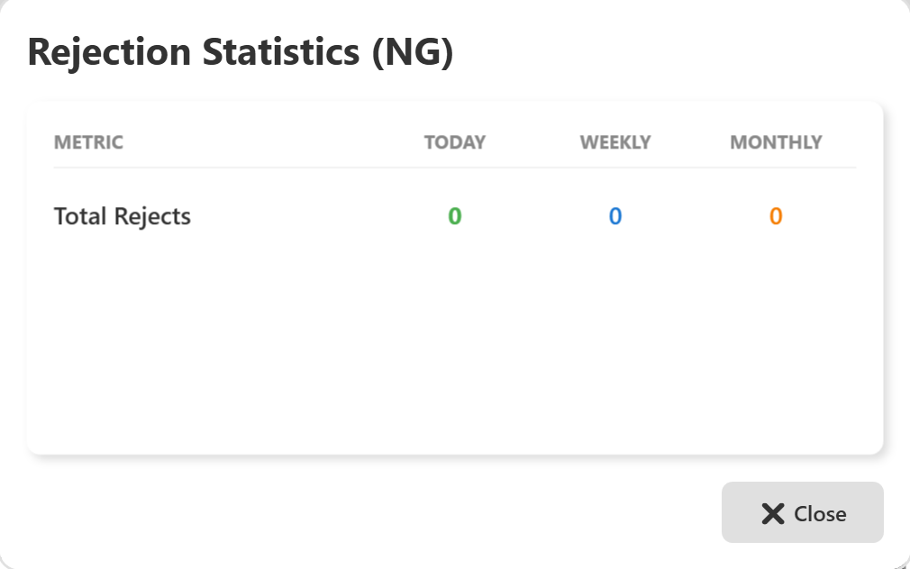

## 12.4 Displayed Metric

### **Total Rejects**

• Shows the total number of rejected units (NG).  
• Displays count values for:  
o Current Day (Today)  
o Current Week (Weekly)  
o Current Month (Monthly)

## **Displayed values are color coded:** • Today – shown in green • Weekly – shown in blue • Monthly – shown in orange

## If the values are displayed as **0**, it indicates that: • No units have been rejected, or • Inspection has not started, or • No rejection data is available for the selected time period.

## 12.5 Operator Actions

From this screen, the Operator can:  
• Review total reject count  
• Compare Today, Weekly, and Monthly rejection values  
• Close the screen after reviewing the data

No editing, control, or configuration actions are available on this screen.

## 12.6 Close Action

## • Click the **Close (X)** button at the bottom-right of the screen to exit the Rejection Statistics (NG) view. • The system will return to the previous OEE Dashboard screen.

## 12.7 Important Notes for Operator

• Increase in NG count indicates potential quality or process issues.  
• Repeated or sudden rise in rejects should be reported immediately to the supervisor or quality team.  
• Compare NG values with **Input Statistics** and **Production Quality (OK)** data for better analysis.  
• If NG remains **0** while inspection is running, verify camera and inspection process status.

**13 Efficiency Breakdown Details**

## 13.1 Screen Name

**Efficiency Breakdown Details**

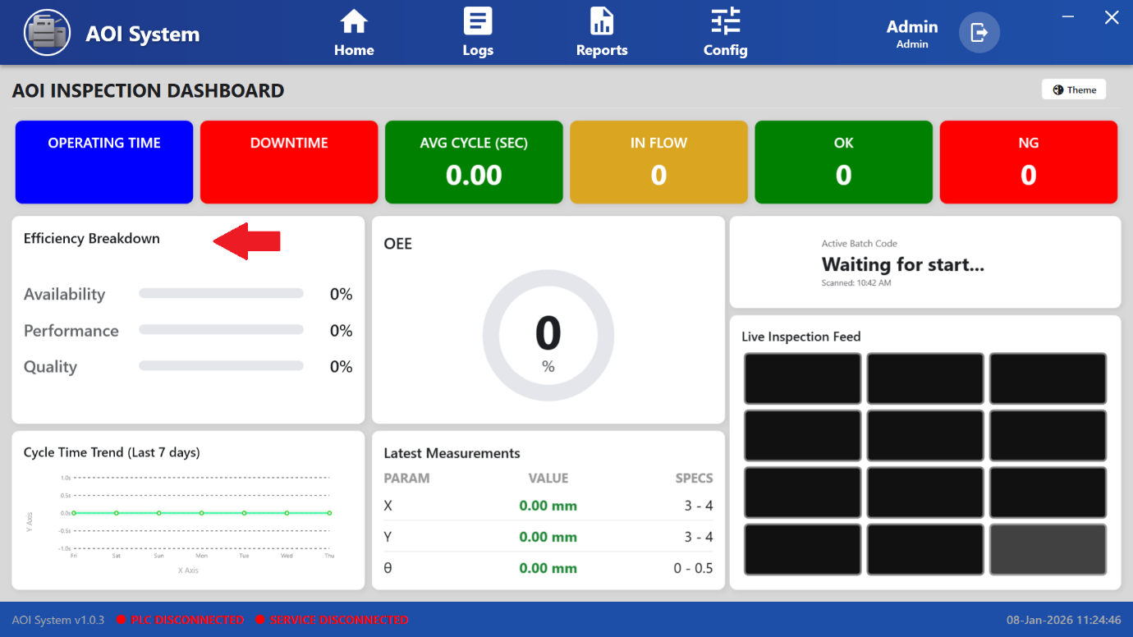

## 13.2 Purpose of the Screen

## The Efficiency Breakdown Details screen displays detailed efficiency values that are used to calculate the overall OEE. It helps the Operator understand the contribution of Availability, Performance, and Quality to system efficiency. This screen is view-only and used for monitoring and analysis.

## 13.3 Screen Overview

The screen displays efficiency data in a tabular format with the following columns:  
• Metric  
• Today  
• Weekly  
• Monthly

All values are displayed in **percentage (%)**.

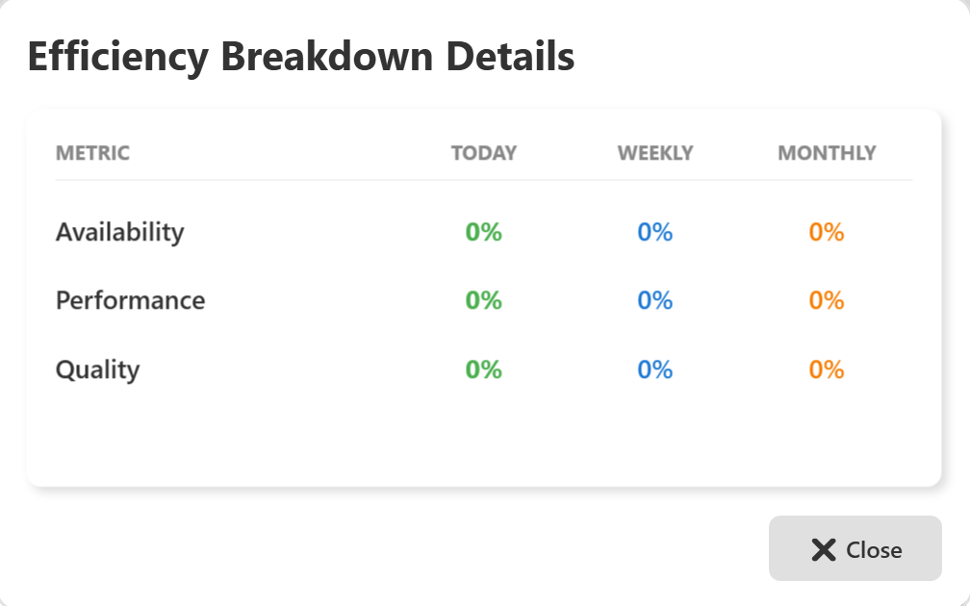

## 13.4 Displayed Metrics

### **1. Availability**

### • Shows how much time the machine was available for operation. • Lower value indicates higher machine downtime.

### **2. Performance**

### • Shows how efficiently the machine is running compared to the expected cycle time. • Lower value indicates slower production or cycle delays.

### **3. Quality**

• Shows the percentage of good units (OK) compared to total input.  
• Lower value indicates higher rejection (NG) rate.

Displayed values are color coded:  
• Today – shown in green  
• Weekly – shown in blue  
• Monthly – shown in orange

If the values are displayed as **0%**, it indicates that:  
• Production has not started, or  
• No valid efficiency data is available, or  
• PLC or service connection is not active.

## 13.5 Operator Actions

From this screen, the Operator can:  
• View Availability, Performance, and Quality values  
• Compare Today, Weekly, and Monthly efficiency percentages  
• Identify which factor is affecting overall efficiency  
• Close the screen after reviewing data

No changes or inputs are allowed on this screen.

**13.6 Close Action**

• Click the **Close (X)** button at the bottom-right of the screen to exit the Efficiency Breakdown Details view.  
• The system will return to the OEE Inspection Dashboard.

**13.7 Important Notes for Operator**

• All three parameters directly affect the OEE value.  
• Low **Availability** → Check Downtime Statistics.  
• Low **Performance** → Check Avg Cycle (Sec) data.  
• Low **Quality** → Check OK and NG statistics.  
• If all values remain **0%**, verify PLC and Service connection status before starting inspection.

**14**  **OEE Score Statistics**

## 14.1 Screen Name

OEE Score Statistics  
(Opened when Operator clicks on **OEE Score**)

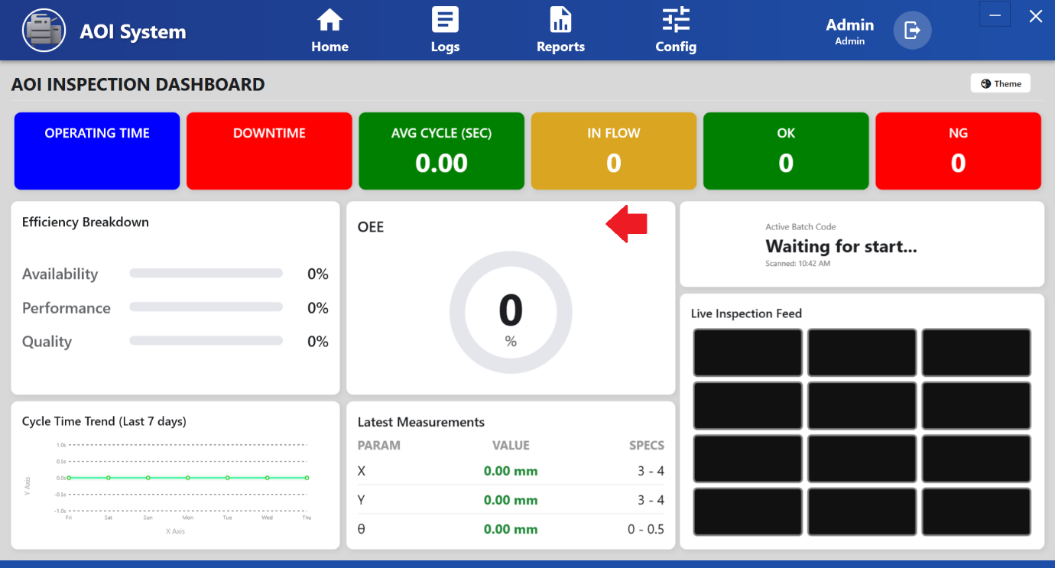

## 14.2 Purpose of the Screen

## The OEE Score Statistics screen displays the Overall Equipment Effectiveness (OEE) percentage of the system. It provides a single performance indicator representing the overall efficiency of the inspection process. This screen is view-only and used for monitoring overall production performance.

## 14.3 Screen Overview

The screen displays OEE data in a simple tabular format with the following columns:  
• Metric  
• Today  
• Weekly  
• Monthly

All values are displayed in **percentage (%)**.

Only one main metric, **OEE Score**, is shown on this screen.

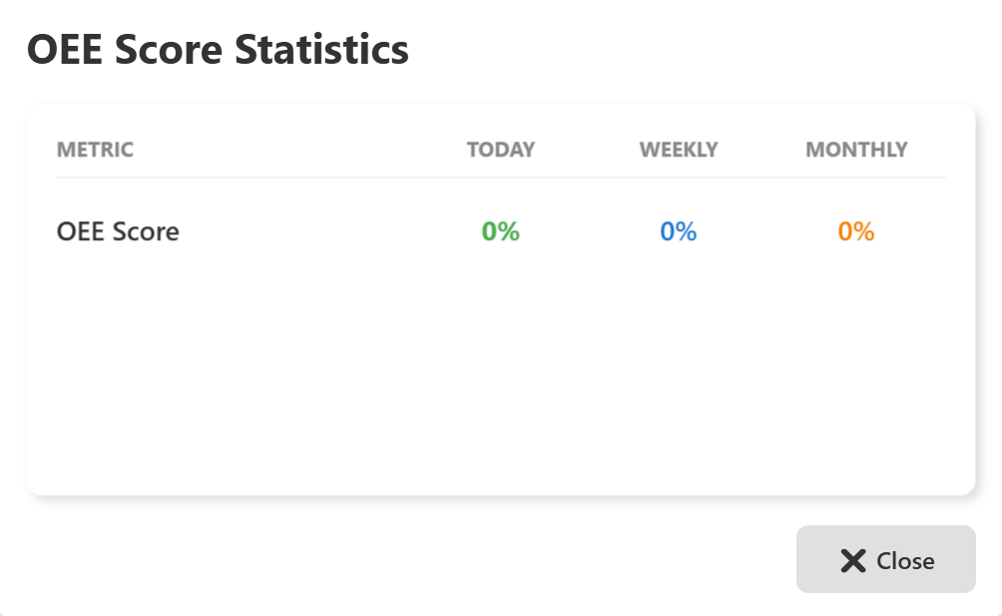

## 14.4 Displayed Metric

### **1. OEE Score**

• Shows the overall efficiency percentage of the AOI system.  
• Displays values for:  
o Current Day (Today)  
o Current Week (Weekly)  
o Current Month (Monthly)

## Displayed values are color coded: • Today – shown in green • Weekly – shown in blue • Monthly – shown in orange

## The OEE score is calculated based on: • Availability • Performance • Quality

## If the value is displayed as **0%**, it indicates that: • Production has not started, or • Required efficiency data is not available, or • PLC or service connection is not active.

## 14.5 Operator Actions

From this screen, the Operator can:  
• View overall OEE percentage  
• Compare Today, Weekly, and Monthly OEE values  
• Monitor overall inspection efficiency  
• Close the screen after reviewing data

No editing, control, or configuration actions are available on this screen.

## 14.6 Close Action

## • Click the **Close (X)** button at the bottom-right of the screen to exit the OEE Score Statistics view. • The system will return to the OEE Inspection Dashboard.

## 14.7 Important Notes for Operator

• OEE score depends on Availability, Performance, and Quality values.  
• Low OEE indicates that one or more efficiency factors need attention.  
• Check **Efficiency Breakdown Details** to identify the reason for low OEE.  
• If OEE remains **0%** while inspection is running, verify:  
o Machine running status  
o PLC and Service connection status

**15 Mode of Operation**

### **15.1 Screen Overview**

When the Operator selects **Mode of Operation from the Home section**, the Mode of Operation screen is displayed.  
This screen is used to select and control the operational mode of the AOI system during production and maintenance activities.

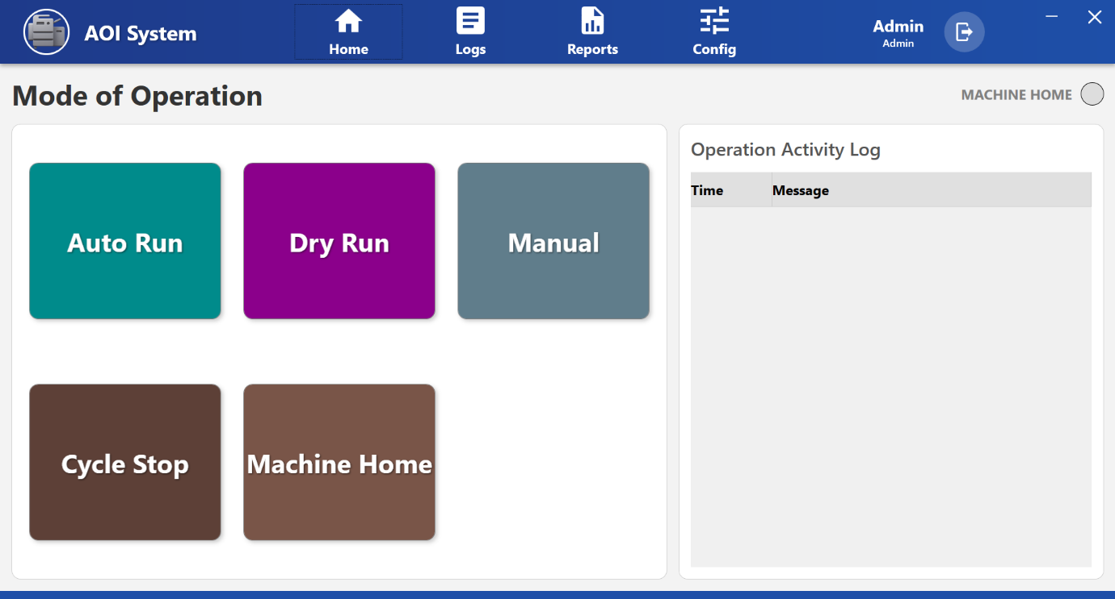

### **15.2 Available Operation Modes**

The following operation modes and controls are available on this screen:

### **15.3 Auto Run**

• Used for fully automatic inspection operation.  
• The machine runs continuously based on predefined inspection parameters.  
• Recommended for normal production runs.

### **15.4 Dry Run**

• Used to test machine movement without performing actual inspection.  
• Helpful for setup verification, debugging, and maintenance checks.  
• No inspection results are generated in this mode.

### **15.5 Manual**

• Allows the operator to manually control machine functions.  
• Used mainly for setup, calibration, and maintenance activities.  
• Requires trained personnel to operate safely.

### **15.6 Cycle Stop**

• Stops the machine operation after completing the current inspection cycle.  
• Prevents sudden interruption during an active inspection process.  
• Helps in safe and controlled machine stopping.

### **15.7 Mass RTO (Return to Origin)**

• Used to perform a mass Return to Origin (RTO) operation.  
• All relevant machine axes move back to their reference/home position.  
• Recommended after maintenance or before starting production.

### **15.8 Operation Activity Log**

On the right side of the screen, the Operation Activity Log panel is displayed.  
• Displays time-stamped operation messages and system status updates.  
• Helps the Operator track mode changes and machine actions.  
• Useful for troubleshooting and operation verification.

### **15.9 System Status Indicators**

• Machine Home indicator (green) shows that the machine is in home position and ready for operation.  
• Bottom status bar displays:  
o System version  
o PLC connection status  
o Service connection status  
o Current date and time

### **15.10 Operator Guidelines**

• Always select the correct operation mode before starting production.  
• Use **Manual** and **Dry Run** modes only with proper training and authorization.  
• Monitor the Operation Activity Log to confirm system actions.  
• If PLC or Service is disconnected, do not start machine operation and inform maintenance.

**16 Auto Run Mode Selection**

**16.1 Screen Overview**

When the operator clicks on **Auto Run** in the Mode of Operation screen, the AOI system switches to **automatic operation mode**.

### **16.2 System Behavior After Selecting Auto Run**

* The **Auto Run** button becomes active, indicating that automatic mode has been selected.
* The system prepares to execute inspection cycles automatically based on the configured parameters.
* No manual intervention is required during normal operation.

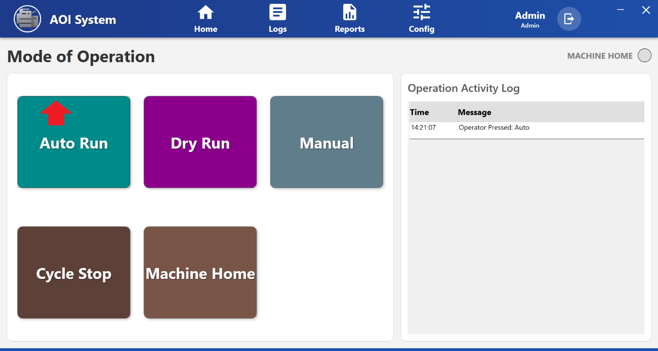

### **16.3 Operation Activity Log Update**

Once **Auto Run** is selected, an entry is recorded in the **Operation Activity Log** panel on the right side of the screen.

**Example log message:**

Operator started Auto Run.

This log entry includes:

* **Time** of the action
* **Message** describing the operation performed

The activity log helps in tracking operator actions and verifying system operations.

### **16.4 Machine Status Indication**

* The **Machine Home** indicator (green) confirms that the machine is in the home position and ready for operation.
* If the PLC connection is not available, the system status bar displays **PLC Disconnected**, and automatic operation should not be started.

### **16.5 Operator Guidelines**

* Ensure all safety checks and prerequisites are completed before selecting **Auto Run**.
* Verify PLC connectivity before starting automatic operation.
* Monitor the **Operation Activity Log** to confirm successful mode activation.
* In case of abnormal behavior, use **Cycle Stop** to safely stop the operation.

**17 Dry Run Mode Selection**

**17.1 Screen Overview**

When the operator clicks on **Dry Run** in the Mode of Operation screen, the AOI system switches to **Dry Run mode**.

### **17.2 System Behavior After Selecting Dry Run**

* The system enters **test operation mode** without performing actual inspection.
* Machine movements are executed based on configured paths and sequences.
* No inspection results or production data are generated in this mode.

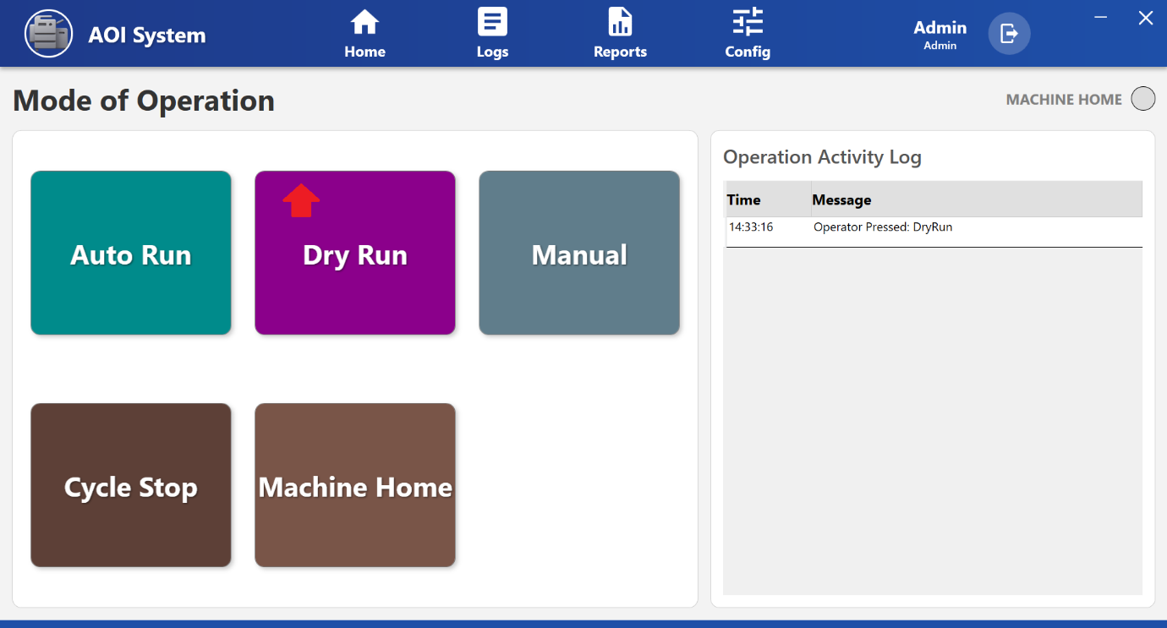

### **17.3 Operation Activity Log Update**

After selecting **Dry Run**, the system records the action in the **Operation Activity Log**.

**Example log message:**

Operator started Dry Run.

This log entry contains:

* **Time** when the mode was activated
* **Message** describing the operator action

The activity log ensures traceability of operational changes.

### **17.4 Typical Use Cases**

* Machine setup verification
* Motion path and sequence testing
* Maintenance and troubleshooting activities
* Operator training and validation

### **17.5 Operator Guidelines**

* Use **Dry Run** only after ensuring the work area is clear.
* Do not load production material during Dry Run.
* Monitor machine movement closely during test operation.
* Switch to **Auto Run** only after successful Dry Run verification.

**18 Manual Operation Screen**

## 18.1 Screen Overview

The **Manual Operation Screen** allows the operator to manually control individual machine movements and actuators.  
This screen is mainly used during **machine setup, adjustment, inspection, and maintenance** when automatic operation is not required.

All controls on this screen respond immediately to operator input, therefore movements must be performed carefully and under continuous observation.

## 18.2 Accessing Manual Operation Screen

1. Open the **Mode of Operation** screen.
2. Select **Manual**.
3. The system navigates to the **Manual Operation Screen**, displaying all available manual controls.

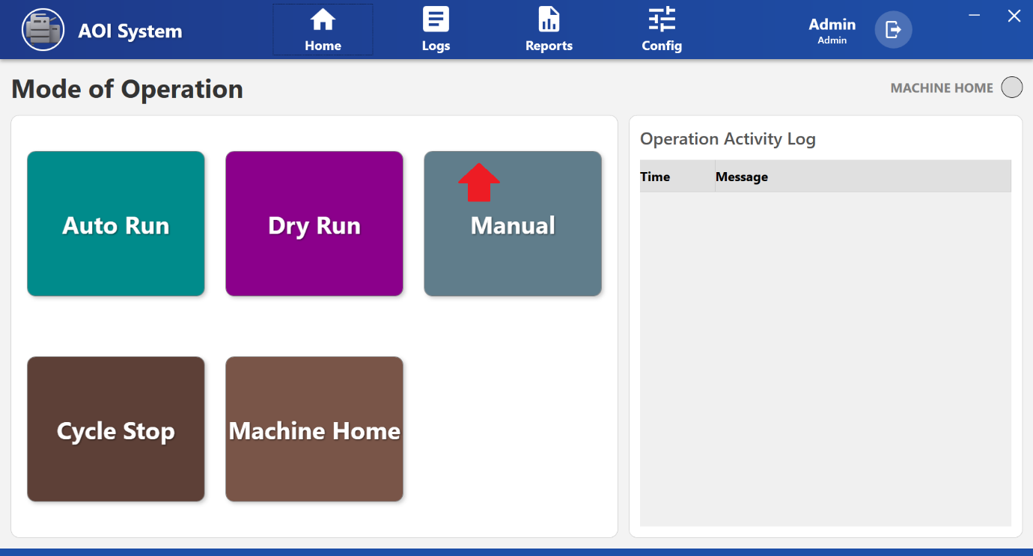

## 18.3 Screen Layout Description

The Manual Operation Screen is divided into clearly defined sections.  
Each section is designed to control a specific function of the machine.

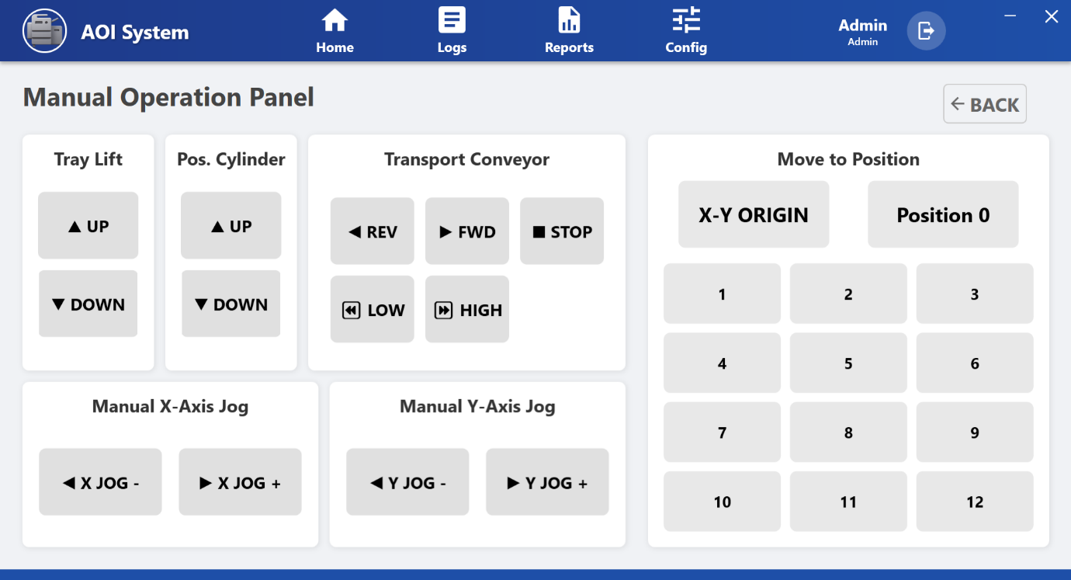

### **18.4 Tray Lift Section**

**Purpose:**  
Controls the vertical movement of the tray lift mechanism.

**Operator Controls:**

* **UP** – Moves the tray upward
* **DOWN** – Moves the tray downward

**Operator Use Case:**  
Used during tray loading, unloading, and height adjustment.

### **18.5 Positioning Cylinder Section**

**Purpose:**  
Controls the positioning cylinder used for component alignment or holding.

**Operator Controls:**

* **UP** – Extends the positioning cylinder
* **DOWN** – Retracts the positioning cylinder

**Operator Use Case:**  
Used to position components correctly during manual setup.

### **18.6 Transport Conveyor Section**

**Purpose:**  
Provides manual control over conveyor movement and speed.

**Operator Controls:**

* **REV** – Moves conveyor in reverse direction
* **FWD** – Moves conveyor in forward direction
* **STOP** – Stops conveyor immediately
* **LOW** – Sets low conveyor speed
* **HIGH** – Sets high conveyor speed

**Operator Use Case:**  
Used to manually move material during setup, inspection, or fault recovery.

### **18.7 Manual X-Axis Jog Section**

**Purpose:**  
Allows fine manual movement of the X-axis.

**Operator Controls:**

* **X JOG -** – Moves X-axis in negative direction
* **X JOG +** – Moves X-axis in positive direction

**Operator Use Case:**  
Used for precise alignment and calibration.

### **18.8 Manual Y-Axis Jog Section**

**Purpose:**  
Allows fine manual movement of the Y-axis.

**Operator Controls:**

* **Y JOG -** – Moves Y-axis in negative direction
* **Y JOG +** – Moves Y-axis in positive direction

**18.9 Operator Use Case:**  
Used for accurate positioning during inspection and setup.

### Move to Position Section

**Purpose:**  
Allows the operator to move the machine to predefined positions.

**18.10 Operator Controls:**

* **X-Y ORIGIN** – Moves machine to home position
* **Position 0** – Moves to reference position
* **Position 1 to 12** – Moves to stored preset positions

**Operator Use Case:**  
Helps in fast and repeatable positioning without manual jogging.

## 18.11 Operator Notes And Precautions

* Ensure the machine is in a safe state before performing manual movements.
* Always monitor axis movement while operating in manual mode.
* Do not use manual mode during active automatic cycles.
* Use emergency stop or STOP button immediately in case of abnormal behavior.

**19 Cycle Stop Screen**

## 19.1 Screen Overview

The **Cycle Stop** function allows the operator to safely stop the currently running machine cycle.  
When Cycle Stop is activated, the machine completes the ongoing safe step and then halts further operation.

This function is used when the operator needs to **pause production without abruptly stopping the machine**.

## 19.2 Accessing Cycle Stop

1. Navigate to the **Mode of Operation** screen.
2. Click on **Cycle Stop**.
3. The system immediately processes the cycle stop request and updates the machine status.

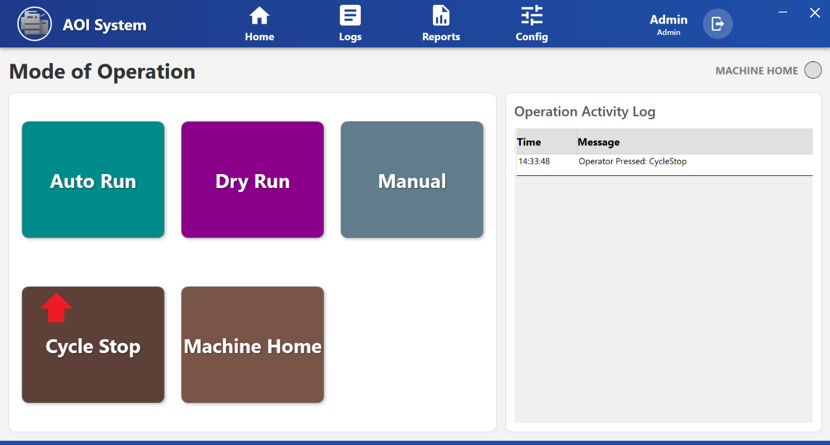

## 19.3 Screen Behavior After Cycle Stop

After the operator clicks **Cycle Stop**, the following behavior is observed:

* The machine stops executing the automatic cycle in a controlled manner.
* No new cycles are started.
* The **Machine Home indicator** changes status to show that the machine is no longer in active run state.
* The system remains powered and responsive for further operator actions.

## 19.4 Operation Activity Log Update

Once Cycle Stop is pressed, an entry is recorded in the **Operation Activity Log**.

**Example Log Entry:**

* **Time:** System timestamp
* **Message:** Operator Pressed: **CycleStop**

This log helps in tracking operator actions for audit and troubleshooting purposes.

## 19.5 Operator Actions After Cycle Stop

After the cycle is stopped, the operator can:

* Switch to **Manual Mode** for inspection or adjustment
* Perform **Machine Home** operation if required
* Resume operation by selecting **Auto Run** or **Dry Run** (as per process requirement)

## 19.6 Operator Notes And Precautions

* Cycle Stop should be used for **normal operational stopping** of the machine.
* Do not use Cycle Stop as an emergency stop.
* Always wait for machine motion to completely stop before opening guards or accessing machine components.
* Verify machine status before restarting the operation.

# **19 Machine Home Screen**

## 19.1 Screen Overview

The **Machine Home** function is used to move all machine axes and mechanisms to their predefined **home (reference) positions**.  
This operation ensures that the machine starts from a known and safe position before any automatic or manual operation.

Machine Home is typically performed:

* At the start of a shift
* After power ON or system restart
* After a Cycle Stop or fault recovery

## 19.2 Accessing Machine Home

1. Navigate to the **Mode of Operation** screen.
2. Click on **Machine Home**.
3. The system initiates the homing sequence for the machine.

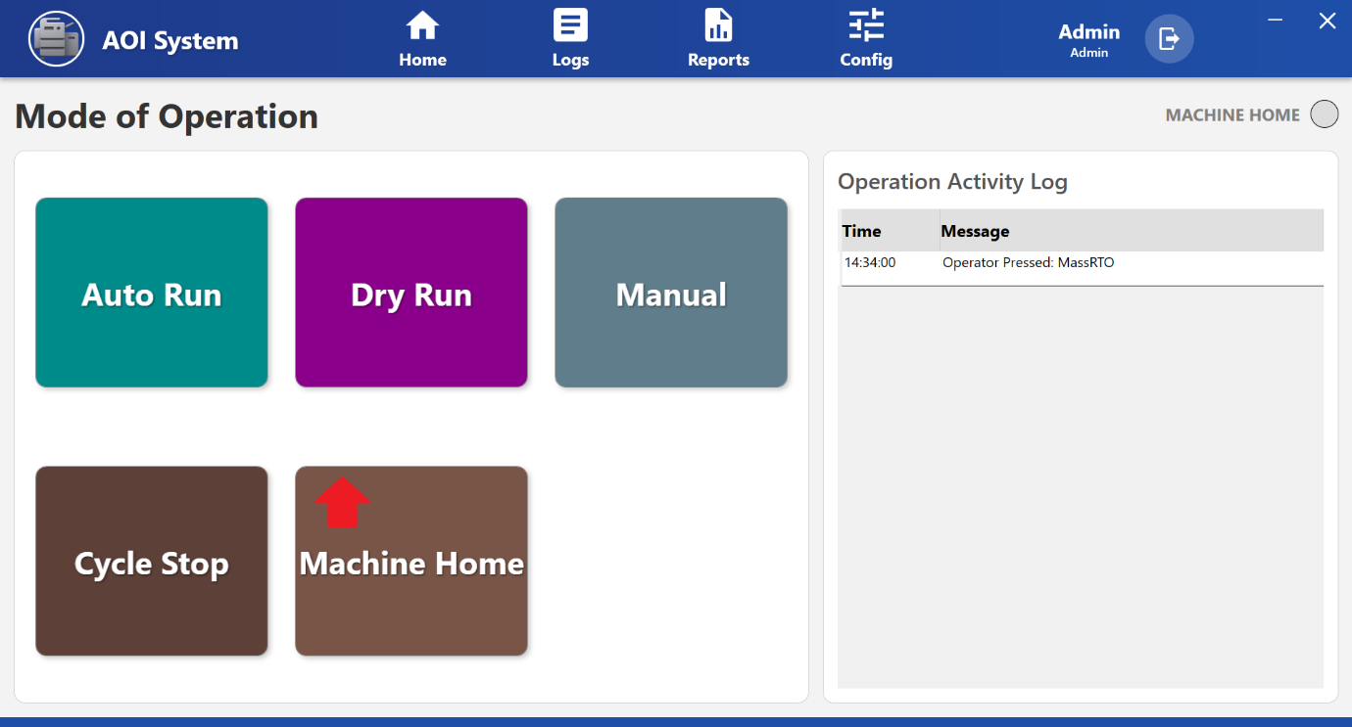

## 19.3 Screen Behavior After Machine Home Selection

Once **Machine Home** is selected, the following behavior is observed:

* The machine begins moving axes to their predefined home positions.
* All movements are executed in a controlled and sequential manner.
* During the homing process, operator input for other modes is restricted.
* The **Machine Home indicator** updates to reflect the homing status.

## 19.4 Operation Activity Log Update

When the operator presses **Machine Home**, an entry is recorded in the **Operation Activity Log**.

**Example Log Entry:**

* **Time:** System timestamp
* **Message:** Operator Pressed: MachineHome

This log entry helps in monitoring operator actions and system events.

## 19.5 Operator Actions During Machine Home

While the machine is performing the homing operation, the operator should:

* Observe all axis movements carefully.
* Ensure no obstructions are present in the machine working area.
* Avoid interacting with moving parts.
* Wait until the homing process is fully completed.

**19.6 Operator Actions After Machine Home Completion**

After successful homing, the operator can:

* Select **Auto Run** to start normal production
* Select **Dry Run** for testing without processing
* Switch to **Manual Mode** for adjustments or inspection

**19.7 Operator Notes And Precautions**

* Machine Home must be completed before starting **Auto Run**.
* Do not interrupt the homing process unless an unsafe condition is observed.
* If homing fails or stops abnormally, inform maintenance personnel.
* Ensure safety guards are properly closed before initiating Machine Home.

**20 Servo Parameters**

### **20.1 Screen Overview**

When the Operator selects **Servo Parameters** from the Home menu, the Servo Parameters screen is displayed.  
This screen is used to view and set motion-related parameters and to teach coordinate positions for machine movement.

The screen contains two tabs:  
• **Servo Params**  
• **Set Coords**

### **20.2 Servo Params Tab – Purpose**

The Servo Params tab is used to view and update motion parameters of machine axes.  
These parameters control how the machine moves during operation.

This tab is mainly used for:  
• Speed adjustment  
• Origin offset setting  
• Acceleration and deceleration tuning

### **20.3 Servo Params Tab – Screen Layout**

The Servo Params tab is divided into two main panels:  
• **X-Axis Parameters**  
• **Y-Axis Parameters**

Each panel contains a table with the following columns:  
• Parameter  
• Val (Current Value)  
• Set New (New value input field)  
• SET (Button to apply the new value)

### **20.4 X-Axis and Y-Axis Parameters**

Common parameters displayed for each axis include:

• **Jog Low Speed** (X-Axis)  
Controls the slow jogging speed used during manual movement.

• **Origin Offset**  
Sets the offset from the home reference position.

• **Move Speed**  
Defines the normal movement speed of the axis.

• **Acceleration**  
Controls how quickly the axis reaches the target speed.

• **Deceleration**  
Controls how quickly the axis slows down before stopping.

Current values are shown in the **Val** column.  
New values can be entered in the **Set New** field and applied using the **SET** button.

### **20.5 Saving Servo Parameters**

After updating required parameters:  
• Click the **SAVE** button at the bottom of the screen.  
• The system stores the updated servo parameters.

If SAVE is not clicked, parameter changes may not be applied permanently.

### **20.6 Set Coords Tab – Purpose (Position Teaching)**

The Set Coords tab is used for **Position Teaching**, where machine coordinates are stored for inspection or movement sequences.  
It allows the Operator or technician to define and save multiple machine positions.

This is mainly used during:  
• Setup  
• Calibration  
• Program configuration

### **20.7 Set Coords Tab – Screen Layout**

The Position Teaching screen displays a table with the following columns:  
• ID  
• Position Name  
• Sequence  
• Saved X  
• Saved Y  
• Action

At the top-right, **Live X** and **Live Y** values display the current machine position in real time.

### **20.8 Teaching and Writing Positions**

For each position row:

• **TEACH Button**  
Reads the current Live X and Live Y position and temporarily assigns it to that position.

• **WRITE Button**  
Saves the taught position permanently to the system.

• **Sequence Field**  
Defines the movement order of positions during automatic operation.

Saved coordinates are displayed in green under **Saved X** and **Saved Y**.

### **20.9 Jog and Origin Controls**

At the bottom of the screen, manual movement controls are available:

• **X-Y ORIGIN**  
Moves both axes to the home (origin) position.

• **X JOG – / X JOG +**  
Moves X-axis in negative or positive direction manually.

• **Y JOG – / Y JOG +**  
Moves Y-axis in negative or positive direction manually.

These buttons are used for accurate positioning during teaching.

### **20.10 Saving Taught Coordinates**

After teaching and writing positions:  
• Click the **SAVE** button at the bottom-right of the screen.  
• The system stores all taught coordinates and sequence settings.

### **20.11 Operator Actions**

From the Servo Parameters screen, the Operator can:  
• View and adjust servo motion parameters  
• Teach new coordinate positions  
• Save position sequences  
• Manually jog machine axes for setup

### **20.12 Operator Guidelines and Safety Notes**

• Change servo parameters only if authorized and trained.  
• Incorrect values may cause abnormal movement or machine damage.  
• Always use low speed while jogging during teaching.  
• After teaching positions, always press **WRITE** and then **SAVE**.  
• If abnormal motion occurs, stop operation and inform maintenance immediately.

**21 PLC I/O Monitor**

### **21.1 Screen Overview**

When the Operator navigates to **Home → PLC IO**, the PLC I/O Monitor screen is displayed.  
This screen is used to monitor real-time PLC input and output signals of the AOI system.

This screen helps the Operator verify sensor status and machine signal conditions during operation.

### **21.2 Purpose of the Screen**

The PLC I/O Monitor screen is used for:  
• Monitoring real-time PLC Inputs and Outputs  
• Checking whether sensors and actuators are working correctly  
• Troubleshooting machine interlock and signal-related issues

This screen is view-only for Operators.

### **21.3 Screen Layout Overview**

The screen contains the following main sections:  
• Input / Output selection tabs  
• Search field  
• Signal status table

### **21.4 Input and Output Tabs**

At the top of the table, two tabs are available:

• **INPUTS Tab**  
Displays all PLC input signals such as sensors, switches, and feedback signals.

• **OUTPUTS Tab**  
Displays all PLC output signals such as motors, valves, cylinders, and control signals.

The active tab determines which signals are shown in the table.

### **21.5 Search Function**

A **Search** box is available at the top-right of the screen.

• Allows searching signals by name or keyword  
• Helps quickly locate specific PLC signals in large lists  
• Filtering happens in real time while typing

### **21.6 Signal Status Table**

The signal information is displayed in a table with the following columns:

• **Sr No** – Serial number of the signal  
• **Name** – PLC signal tag or identifier  
• **Description** – Functional description of the signal  
• **Status** – Current ON/OFF state of the signal

Status updates automatically based on PLC communication.

### **21.7 Status Indication**

• Active signals are shown as ON  
• Inactive signals are shown as OFF  
• Status reflects real-time PLC data

This helps the Operator confirm whether signals are changing correctly during machine operation.

### **21.8 Operator Actions**

From the PLC I/O Monitor screen, the Operator can:  
• View real-time PLC Inputs  
• View real-time PLC Outputs  
• Search specific signals  
• Observe signal changes during machine operation

No control or modification of signals is allowed from this screen.

### **21.9 Operator Guidelines and Safety Notes**

### **22 Alarm View (Active Alarms Screen)**

### **22.1 Screen Overview**

When the Operator navigates to **Home → Alarm View**, the Active Alarms screen is displayed.  
This screen shows all current system alarms that are affecting machine operation and require attention.

It helps the Operator quickly identify machine faults and take corrective action.

### **22.2 Purpose of the Screen**

The Alarm View screen is used to:  
• Monitor active machine and system alarms  
• Identify fault messages and severity level  
• Track when an alarm was raised and when it was reset  
• Reset the system after fault conditions are cleared

This screen is mainly used for troubleshooting and recovery.

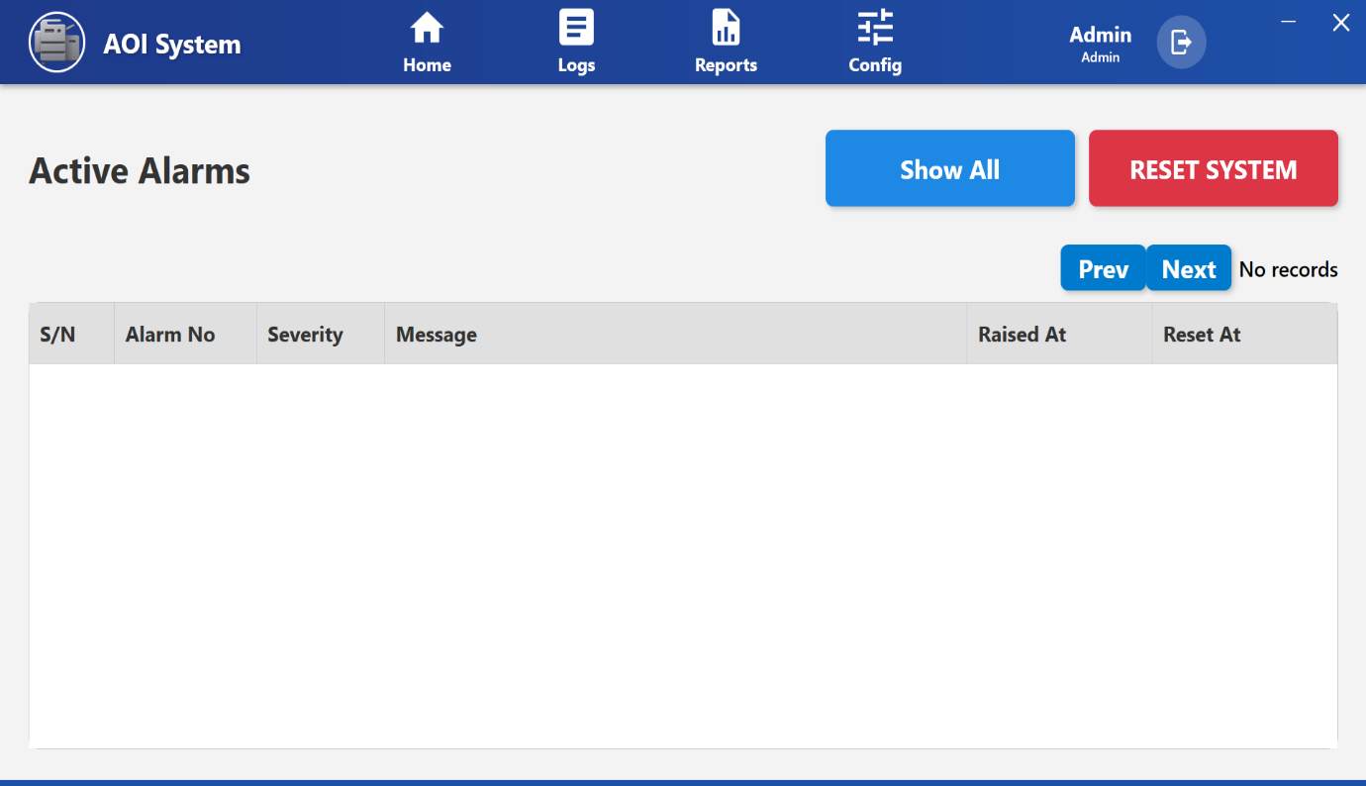

### **22.3 Screen Layout Overview**

The screen contains the following main sections:  
• Alarm control buttons (Show All, Reset System)  
• Alarm records table  
• Pagination controls (Prev / Next)

### **22.4 Alarm Control Buttons**

At the top-right side of the screen, the following buttons are available:

• **Show All**  
Displays all alarm records including current and previous alarms.

• **Reset System**  
Used to reset the system after the fault condition is cleared.  
This allows the machine to return to normal operation.

Reset should be performed only after checking the alarm cause.

### **22.5 Alarm Records Table**

Alarm details are displayed in a table with the following columns:

• **S/N** – Serial number of the alarm record  
• **Alarm No** – Unique alarm identification number  
• **Severity** – Indicates the seriousness of the alarm  
• **Message** – Description of the fault or issue  
• **Raised At** – Date and time when the alarm occurred  
• **Reset At** – Date and time when the alarm was cleared

If no alarms are present, the table may show **No records**.

### **22.6 Pagination Controls**

At the top-right side of the table, **Prev** and **Next** buttons are provided.

• Used to navigate between pages when multiple alarm records are available  
• Helps in reviewing past alarm history when records exceed one page

### **22.7 Operator Actions**

From the Alarm View screen, the Operator can:  
• View active alarm messages  
• Check severity and fault description  
• Review alarm timing information  
• Reset the system after fault resolution  
• Navigate through alarm history pages

The Operator cannot edit or delete alarm records.

### **22.8 Operator Guidelines and Safety Notes**

• Always read the alarm message carefully before taking action.  
• Do not reset the system without resolving the root cause of the alarm.  
• Repeated alarms should be reported to maintenance or engineering.  
• If critical alarms appear, stop production and follow safety procedures.

**23 Time Sync (System Synchronization)**

## 23.1 Navigation Path

Home → Time Sync

The Time Sync option is available under the Home menu.  
The Operator can access this screen by selecting Time Sync from the Home section.

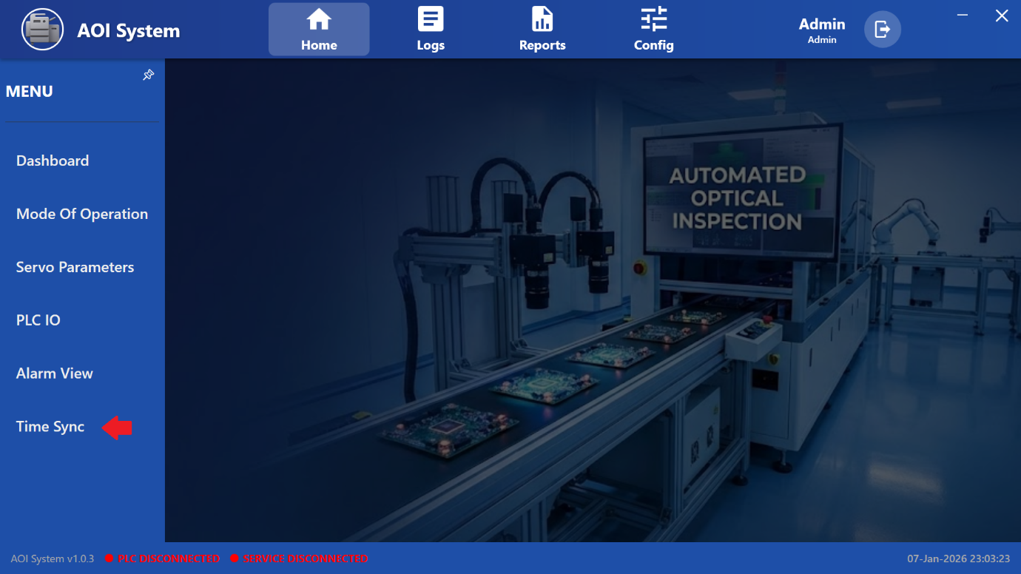

## 23.2 Purpose of Time Sync

The Time Sync function is used to synchronize the date and time between the IPC and the PLC.

Correct time synchronization is important for:  
• Accurate log entries  
• Correct report generation  
• Proper alarm timestamps  
• Audit trail traceability

## 23.3 Screen Name

**System Synchronization**

(This screen opens when Operator clicks on ***Time Sync***)

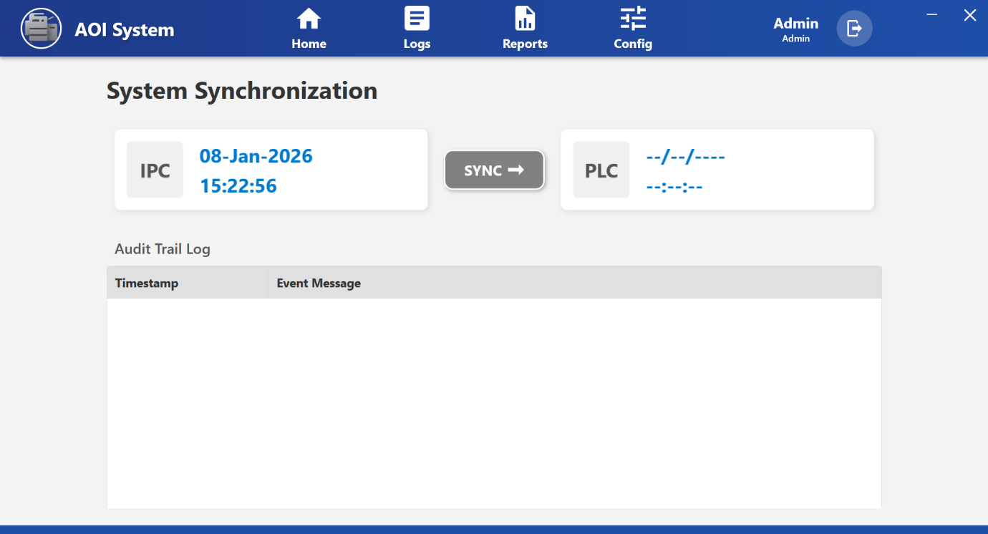

## 23.4 Screen Overview

The System Synchronization screen contains the following main sections:

1. IPC Time Panel
2. PLC Time Panel
3. Sync Button
4. Audit Trail Log

## 23.5 IPC Time Panel

• Displays the current date and time of the IPC (Industrial PC).  
• This time is treated as the reference time for synchronization.

Example:  
• Date: 08-Jan-2026  
• Time: 15:22:56

The IPC time updates continuously.

### **23.6 PLC Time Panel**

• Displays the current date and time of the PLC.  
• Used to compare PLC time with IPC time.  
• If PLC is not connected, date and time may appear as blank or dashed values.

This helps the Operator confirm whether PLC time is synchronized with IPC.

### **23.7 Sync Button (SYNC →)**

• Clicking the **SYNC →** button sends a time synchronization command to the PLC.  
• PLC time is updated to match the IPC time.  
• After synchronization, a record is added to the Audit Trail Log.

Important:  
• Time synchronization should be performed only when PLC is connected.  
• Do not perform sync during active inspection or machine movement.

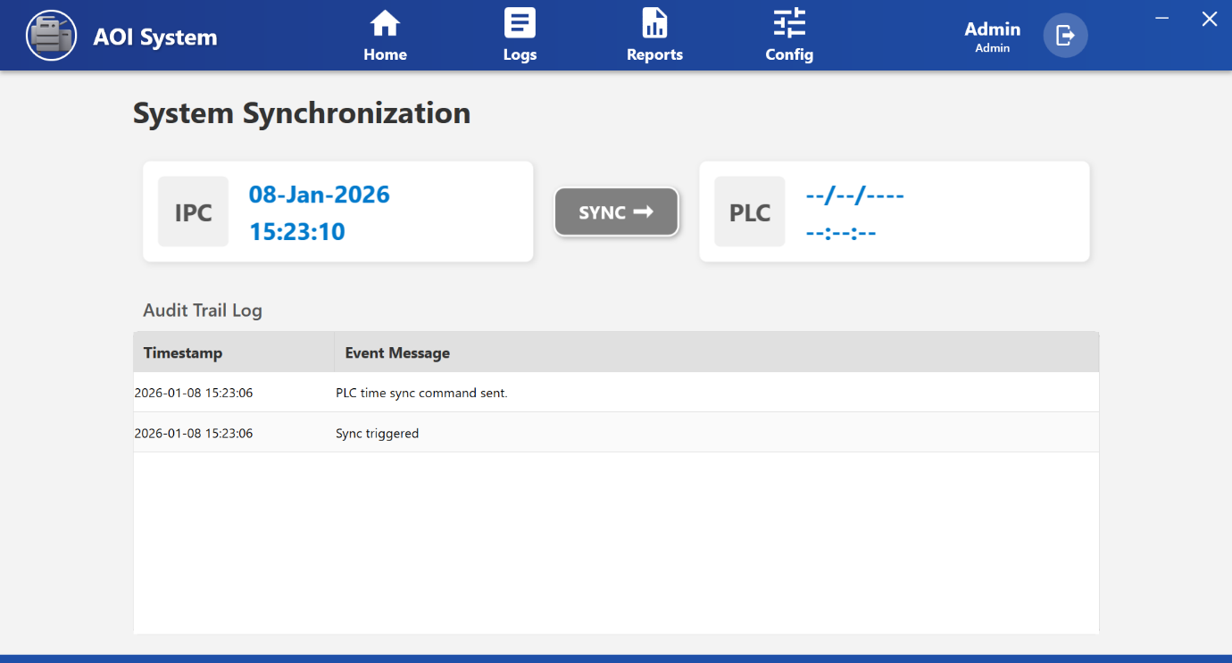

## 23.8 Audit Trail Log

The Audit Trail Log records all synchronization activities.

Displayed columns:  
• **Timestamp** – Date and time when sync was triggered  
• **Event Message** – Description of the sync activity

Example entries:  
• PLC time sync command sent  
• Sync triggered

This log is used for traceability and system audits.

## 23.9 Operator Actions

## From the Time Sync screen, the Operator can: • View IPC date and time • View PLC date and time • Synchronize PLC time with IPC using SYNC button • Review synchronization history in Audit Trail Log

### **23.10 Operator Limitations**

• Operator cannot manually edit IPC or PLC time values.  
• Operator can only synchronize PLC time with IPC time.  
• Manual time configuration is restricted to Admin users.

### **23.11 Important Notes for Operator**

• Always check PLC connection status before clicking SYNC.  
• If PLC is disconnected, do not perform synchronization.  
• Perform Time Sync before starting production for accurate logs and reports.  
• Repeated sync failures should be reported to maintenance or system administrator.

**24 Logs**

## 17.1 Navigation Path

Top Menu → Logs

When the Operator clicks on **Logs** from the top menu bar, a left-side menu panel opens with different log categories.

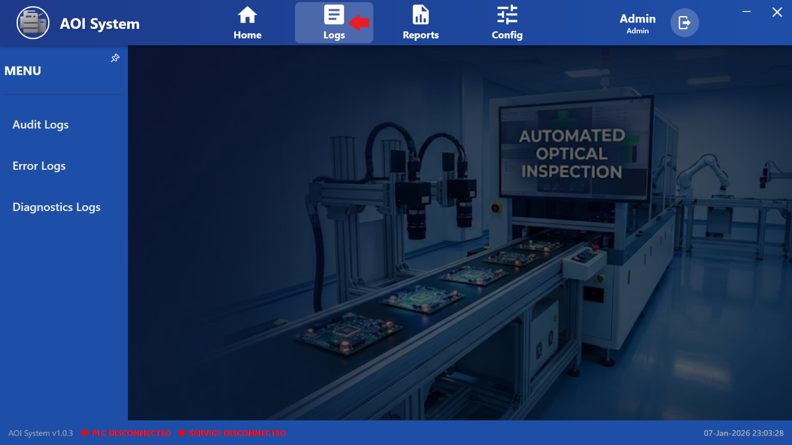

### **24.2 Purpose of Logs**

The Logs section is used to view system history and operational events.  
It helps the Operator understand:  
• What actions occurred in the system  
• When errors or issues happened  
• How the system behaved during operation

All logs are view-only for the Operator.

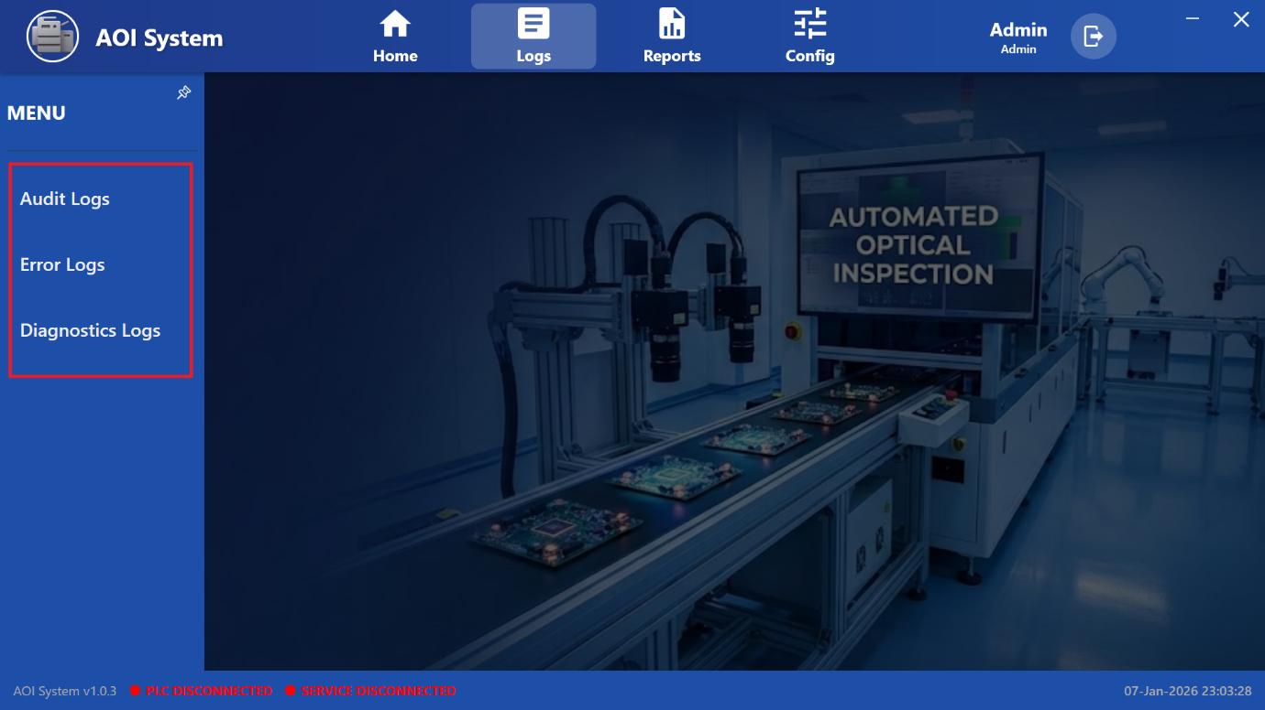

### **24.3 Screen Overview**

After clicking on **Logs**, a side menu appears on the left side of the screen.  
The left menu provides access to different types of logs.

The screen is divided into two main sections:  
• **Left Log Selection Menu** – used to choose log type  
• **Main Display Area** – shows selected log records

Until a log option is selected, the main area shows the background AOI system image.

### **24.4 Available Log Options**

The following log options are available in the left-side menu:

• **Audit Logs**  
• **Error Logs**  
• **Diagnostics Logs**

Each option opens its respective log records in the main display area.

### **24.5 Audit Logs**

**Screen Name:** Audit Logs

**Purpose:**  
Audit Logs record user actions and important system events for traceability.

**Typical Information:**  
• User login and logout  
• Time synchronization actions  
• System operation events

**Operator Actions:**  
• View audit records  
• No editing or deletion allowed

### **24.6 Error Logs**

**Screen Name:** Error Logs

**Purpose:**  
Error Logs record system errors and fault conditions.

**Typical Information:**  
• PLC communication errors  
• System faults  
• Runtime and process errors

**Operator Actions:**  
• View error messages  
• Inform maintenance or administrator when errors occur

### **24.7 Diagnostics Logs**

**Screen Name:** Diagnostics Logs

**Purpose:**  
Diagnostics Logs provide technical and system health information.

**Typical Information:**  
• Hardware status  
• Communication diagnostics  
• Internal system messages

**Operator Actions:**  
• View diagnostic data  
• Share logs with technical support if required

### **24.8 Operator Limitations**

• Operator cannot delete or modify any logs.  
• All logs are automatically generated by the system.  
• Log configuration and maintenance are restricted to Admin users.

### **24.9 Important Notes for Operator**

• Always check **Error Logs** if the system behaves abnormally.  
• Use **Audit Logs** to track important system actions.  
• **Diagnostics Logs** are useful during troubleshooting with support teams.  
• Logs are important for audits and fault analysis.

**25 Audit log**

## 25.1 Screen Name

**Audit Logs**

(Opened when Operator clicks on ***Logs → Audit Logs***)

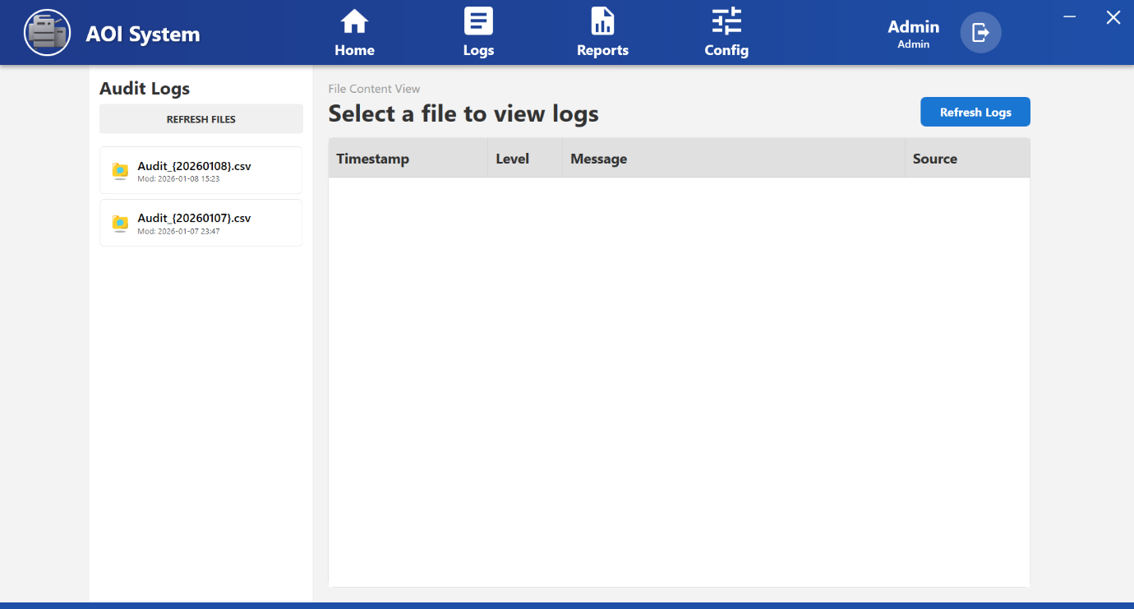

## 25.2 Purpose of the Screen

The **Audit Logs** screen is used to **view audit trail records** generated by the system.  
These logs help track **important user actions and system events** for traceability and audits.

This screen is **view-only** for the Operator.

## 25.3 Screen Layout Overview

The Audit Logs screen is divided into two main sections:

1. **File List Panel (Left Side)**
2. **File Content View (Right Side)**

## 25.4 File List Panel

### **Available Options**

* **Refresh Files**  
  Reloads the list of available audit log files.
* **Audit Log Files (.csv)**  
  Displays audit log files with date-based names  
  (for example: Audit_{20251226}.csv).

Each file also shows:

* **Last Modified Date and Time**

## 25.5 Selecting an Audit Log File

To view audit logs:

1. Click on any **Audit_YYYYMMDD.csv** file from the left panel
2. The selected file content is displayed on the right side

## 25.6 Log Content View

The log data is displayed in a table with the following columns:

* **Timestamp**  
  Date and time when the event occurred.
* **Level**  
  Type or severity of the log entry  
  (for example: Info, Warning, Error).
* **Message**  
  Description of the action or event.
* **Source**  
  Indicates the system component that generated the log.

If no file is selected, the message  
**“Select a file to view logs”** is displayed.

## 25.7 Operator Actions

From the Audit Logs screen, the Operator can:

* Refresh the list of audit log files
* Select and view audit log files
* Review log entries for:
  + Login / logout events
  + Time synchronization actions
  + System-related activities

## 25.8 Operator Limitations

* Operator cannot edit or delete audit logs.
* Log file generation is automatic.
* Audit log configuration is restricted to Admin users.

## 25.9 Important Notes for Operator

* Audit logs are important for **compliance and traceability**.
* Always review audit logs if:
  + Unexpected system behavior occurs
  + Time sync or critical actions are questioned
* Share relevant log details with the administrator when required.

**26** **Error Logs**

## 26.1 Screen Name

**Error Logs**

(Opened when Operator clicks on **Logs → Error Logs**)

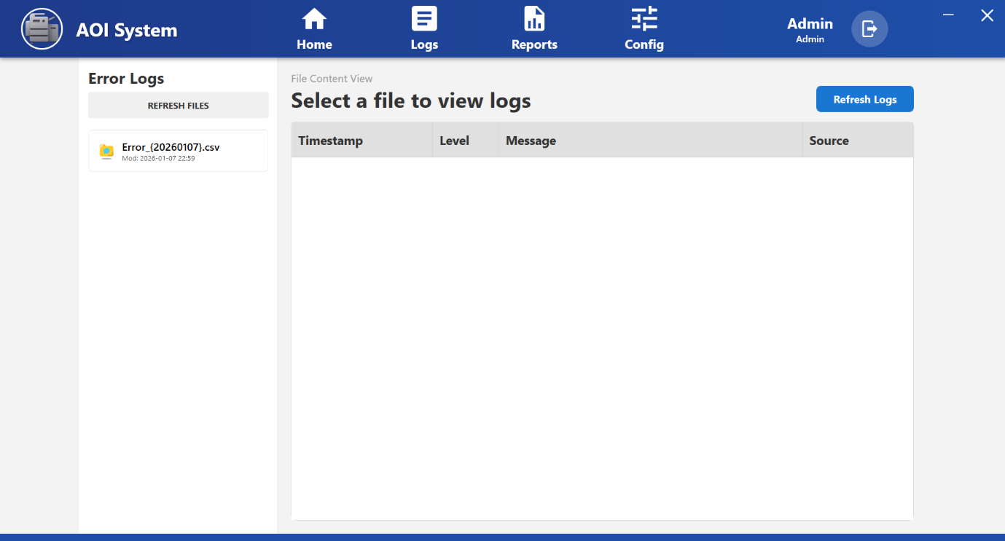

**26.2 Purpose of the Screen**

The **Error Logs** screen is used to **view system error records**.  
It helps the Operator identify **system-level problems** that may affect inspection or operation.

This screen is **view-only** for the Operator.

## 26.3 Navigation Flow

**Logs → Error Logs → Select Error File (.csv)**

After selecting an error log file, the system displays the list of recorded errors.

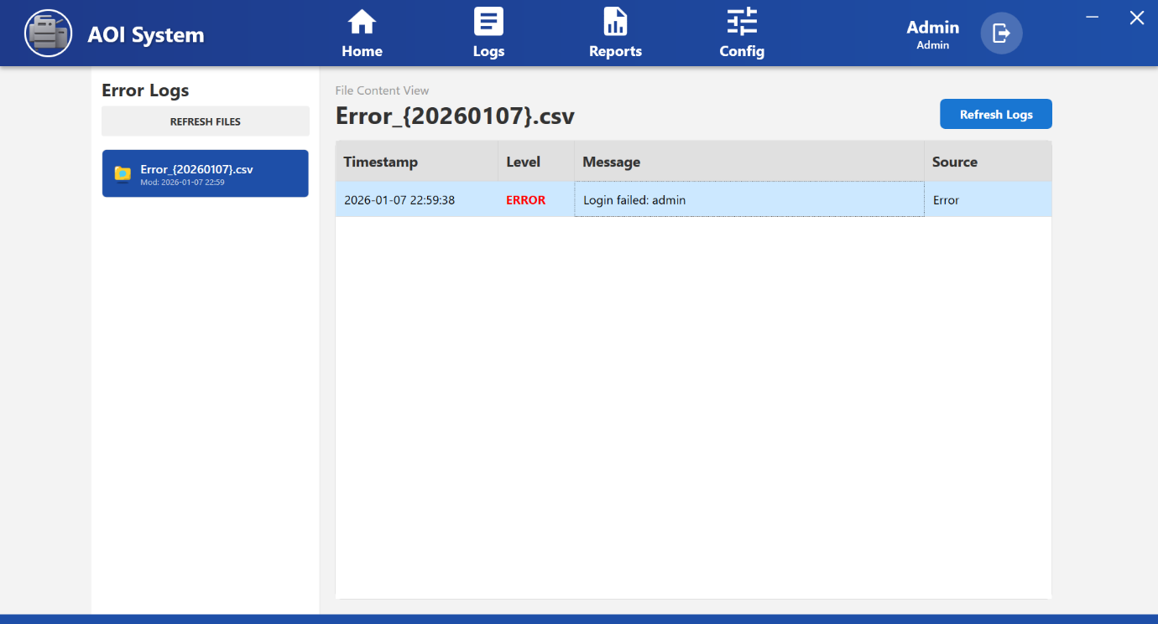

## 26.4 Screen Layout Overview

The Error Logs screen is divided into two sections:

1. **File List Panel (Left Side)**
2. **Error Log Content View (Right Side)**

## 26.5 File List Panel

### **Available Options**

* **Refresh Files**  
  Reloads the list of available error log files.
* **Error Log Files**  
  Displays error log files with date-based names  
  (for example: Error_{20251226}.csv).

Each file shows:

* **Last Modified Date and Time**

## 26.6 Selecting an Error Log File

To view error details:

1. Click on an **Error_YYYYMMDD.csv** file from the left panel
2. The error entries are displayed in the right-side table

## 26.7 Error Log Content View

The error list is displayed in a table with the following columns:

* **Timestamp**  
  Date and time when the error occurred.
* **Level**  
  Error severity level (for example: **ERROR**).
* **Message**  
  Description of the error  
  (for example: missing folder, communication issue, system failure).
* **Source**  
  Indicates the source of the error (system component).

## 26.8 Operator Actions

From the Error Logs screen, the Operator can:

* Refresh the error log file list
* Select and view error log files
* Review error messages and timestamps
* Identify repeated or critical errors

## 26.9 Operator Responsibilities

* **Do not ignore repeated ERROR entries**
* Note the **error message and timestamp**
* Inform the supervisor, maintenance, or administrator
* Share error details for troubleshooting

## 26.10 Operator Limitations

* Operator cannot edit or delete error logs.
* Error logs are generated automatically by the system.
* Error handling and fixes are performed by Admin or support team.

## 26.11 Important Notes for Operator

* Red **ERROR** entries indicate serious system issues.
* If errors appear continuously:
  + Stop operation if required
  + Inform support immediately
* Check **PLC connection status** at the bottom of the screen.
* Error Logs are critical for troubleshooting and audits.

**27**  **Diagnostics Log**

## 27.1 Screen Name

**Diagnostics Logs**

(Opened when Operator clicks on ***Logs → Diagnostics Logs***)

## 27.2 Purpose of the Screen

The **Diagnostics Logs** screen is used to **view detailed technical and communication-related logs** generated by the AOI System.  
These logs help in identifying **system health, communication issues, and internal diagnostic errors**.

This screen is mainly used for **troubleshooting and support analysis**.

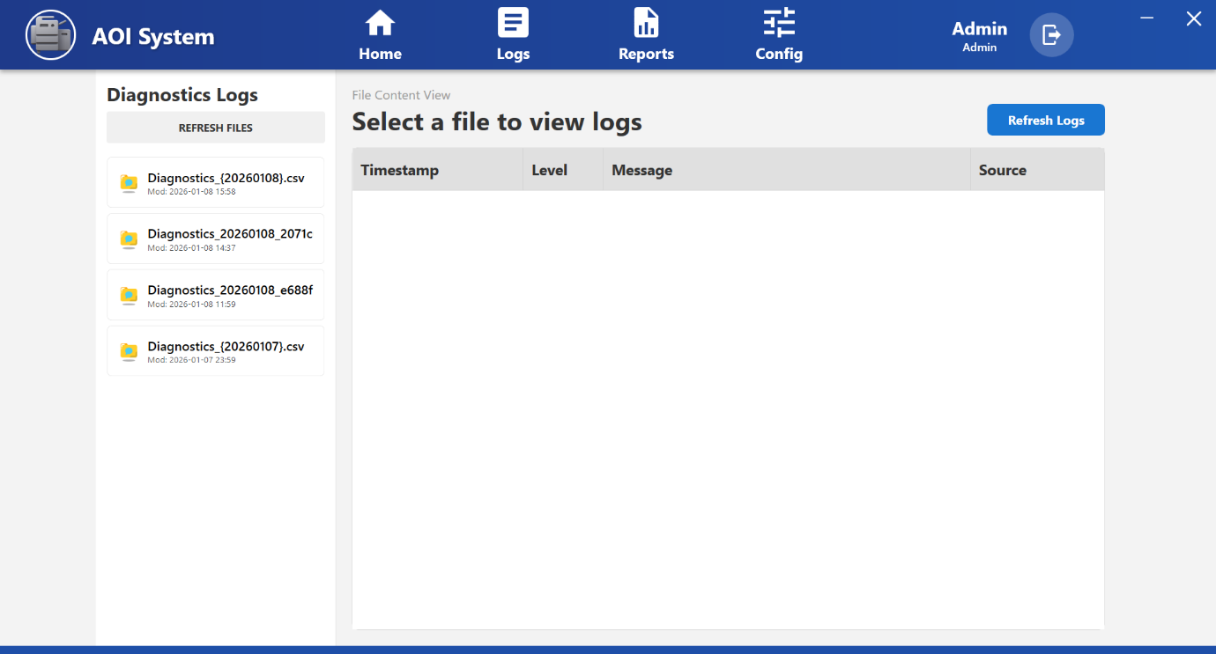

## 27.3 Navigation Flow

**Logs → Diagnostics Logs → Select Diagnostics File (.csv)**

After selecting a diagnostics log file, the system displays detailed diagnostic entries.

## 27.4 Screen Layout Overview

The Diagnostics Logs screen is divided into two main sections:

1. **File List Panel (Left Side)**
2. **Diagnostics Log Content View (Right Side)**

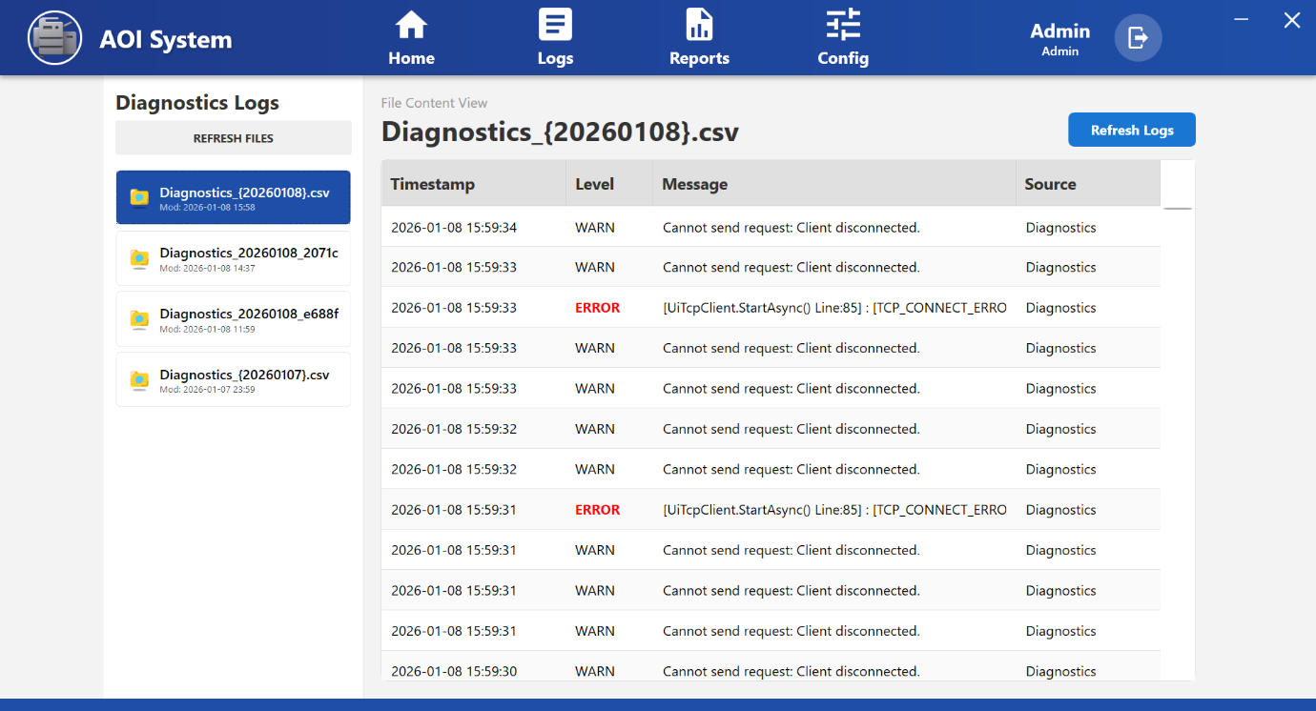

## 27.5 File List Panel

### **Available Options**

* **Refresh Files**  
  Reloads the list of available diagnostics log files.
* **Diagnostics Log Files**  
  Displays diagnostics log files with date-based names  
  (for example: Diagnostics_20251226.csv).

Each file shows:

* **Last Modified Date and Time**

## 27.6 Selecting a Diagnostics Log File

To view diagnostics details:

1. Click on a **Diagnostics_YYYYMMDD.csv** file from the left panel
2. The diagnostics entries are displayed in the right-side table

## 27.7 Diagnostics Log Content View

The diagnostics data is displayed in a table with the following columns:

* **Timestamp**  
  Date and time when the diagnostic event occurred.
* **Level**  
  Severity of the event (for example: **ERROR**).
* **Message**  
  Technical description of the issue  
  (for example: communication failure, request timeout, internal method error).
* **Source**  
  Indicates the system component generating the diagnostic message  
  (for example: Diagnostics, Core Client, TCP Client).

## 27.8 Operator Actions

From the Diagnostics Logs screen, the Operator can:

* Refresh diagnostics log file list
* Select and view diagnostics log files
* Observe repeated or continuous diagnostic errors
* Note timestamps and error messages

## 27.9 Operator Responsibilities

* **Do not attempt to fix technical errors directly**
* Note down:
  + Error message
  + Timestamp
  + File name
* Share diagnostics details with:
  + Maintenance team
  + Administrator
  + Technical support

## 27.10 Operator Limitations

* Operator cannot edit or delete diagnostics logs.
* Diagnostics logs are automatically generated.
* System-level fixes are handled by Admin or support team only.

## 27.11 Important Notes for Operator

* Continuous **ERROR** entries usually indicate:
  + PLC communication failure
  + Network or TCP connection issues
  + Internal service problems
* Always check **PLC connection status** at the bottom of the screen.
* Diagnostics Logs are critical for root cause analysis.

**28 Reports**

### **28.1 Screen Overview**

When the Operator clicks on **Reports** from the top menu bar, a left-side menu is displayed with report options.  
The Reports screen is used to view production-related data and inspection images generated during machine operation.

This screen helps Operators and Supervisors review production history, inspection results, and image records for analysis and traceability.

### **28.2 Navigation Path**

Top Menu → Reports

After clicking Reports, the left-side menu shows different report categories.

## 28.3 Screen Layout Description

The Reports screen is divided into two main sections:  
**• Left Report Selection Menu  
• Main Display Area**

The left menu is used to select the type of report, and the main area displays the selected report data.

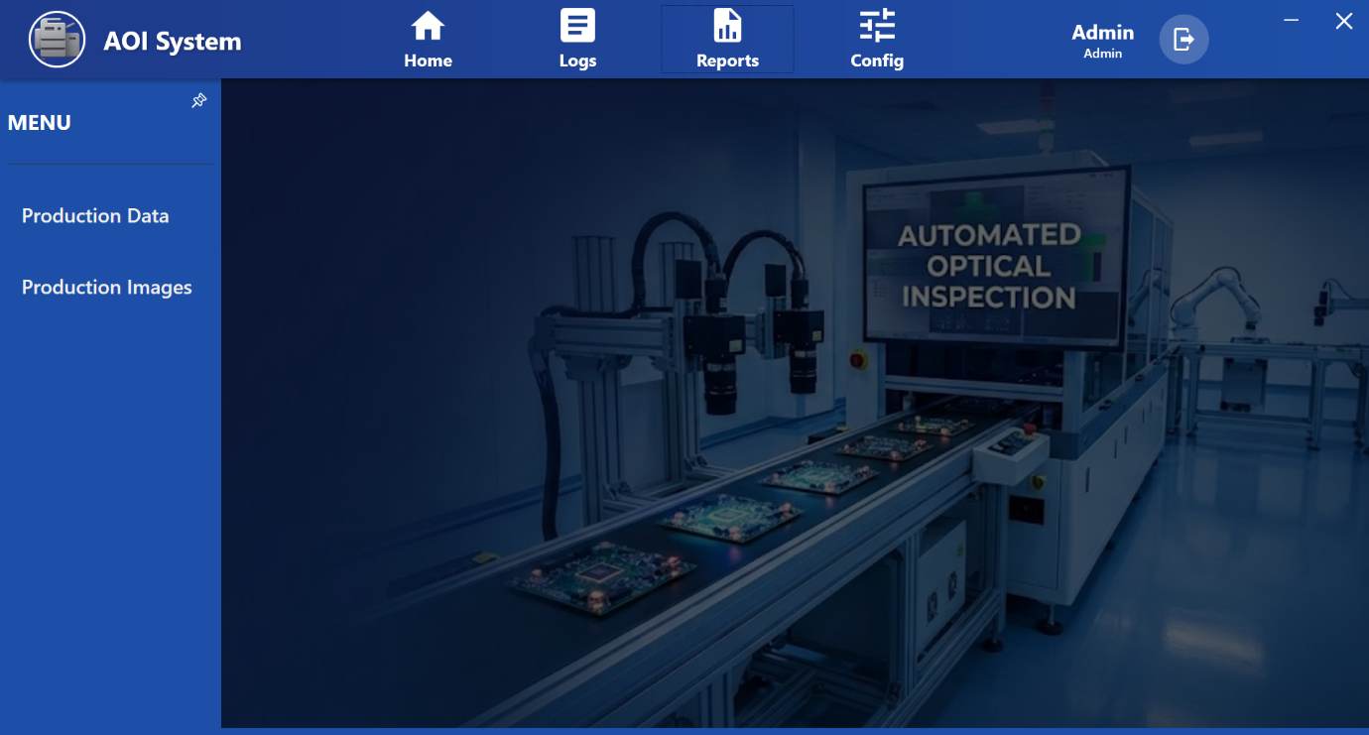

### **28.4 Available Report Options**

The following report options are available in the left-side menu:

• **Production Data**  
• **Production Images**

Each option loads its respective report view in the main display area.

### **28.5 Production Data Report**

**Screen Name:** Production Data

**Purpose:**  
Used to view production and inspection result data.

**Typical Information Displayed:**  
• Batch or job details  
• Inspection counts (OK / NG)  
• Time and date information  
• Production statistics

**Operator Actions:**  
• View production records  
• Scroll through available data  
• Use data for production review and verification

### **28.6 Production Images Report**

**Screen Name:** Production Images

**Purpose:**  
Used to view images captured during inspection.

**Typical Information Displayed:**  
• Board or component images  
• Inspection result reference  
• Image records linked to production events

**Operator Actions:**  
• View inspection images  
• Verify defects visually  
• Use images for quality investigation

### **28.7 Operator Actions**

From the Reports screen, the Operator can:  
• Select report category from the left menu  
• View production data  
• View inspection images  
• Review historical inspection records

Report data is view-only for Operators.

### **28.8 Operator Limitations**

• Operator cannot modify or delete report data.  
• Operator cannot change report configuration.  
• Report format and storage are controlled by Admin settings.

### **28.9 Important Notes for Operator**

• Reports are generated based on stored system data.  
• If data or images are missing, inform system administrator.  
• Use reports for analysis, not for real-time monitoring.  
• Do not rely on reports for immediate machine fault detection.

**29 Production Data (Report Viewer)**

### **29.1 Screen Name**

Report Viewer – Production Data

### **29.2 Navigation Path**

Top Menu → Reports → Production Data

When the Operator clicks on **Reports** from the top menu and then selects **Production Data** from the left-side menu, the Report Viewer screen is displayed.

### **29.3 Purpose of the Screen**

The Production Data screen is used to view and export production and inspection result data for a selected time period.  
It helps the Operator and Supervisor analyze production performance and inspection history.

This screen is used only for viewing and exporting data.

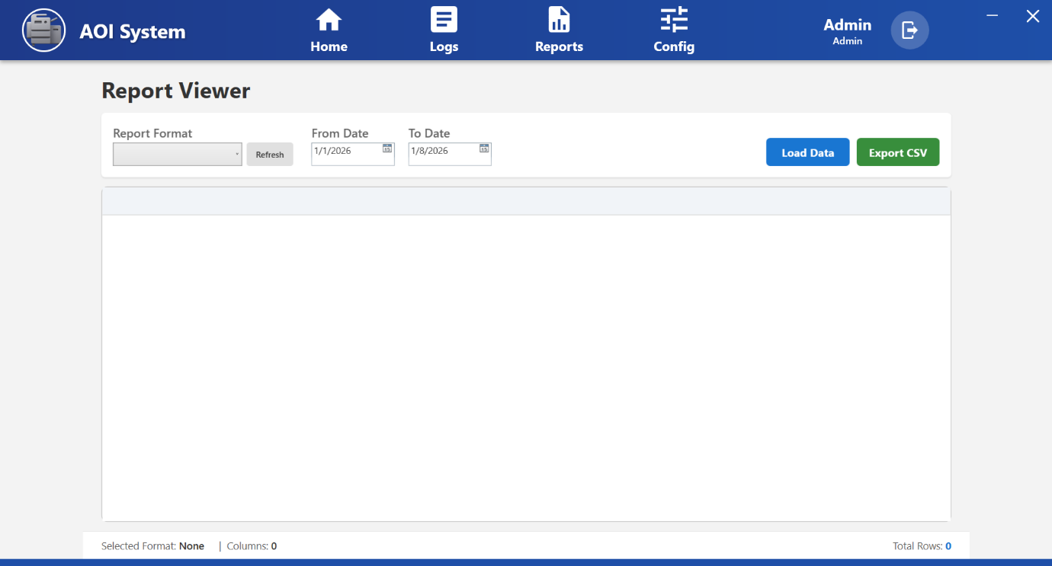

### **29.4 Screen Overview**

The Report Viewer screen consists of two main areas:

1. **Report Selection Panel (Top Section)**
2. **Report Data Display Area (Bottom Section)**

Data is displayed only after loading a valid report format and date range.

### **29.5 Report Selection Panel**

The top panel contains the following controls:

#### ***29.5.1 Report Format***

• Dropdown list used to select a predefined report format.  
• Report formats are created in the Report Configuration section by Admin.

**Operator Action:**  
Select the required report format before loading data.

#### ***29.5.2 From Date and To Date***

• Used to select the start and end date for report data.  
• Defines the time period for which production data will be shown.

**Operator Action:**  
Select appropriate date range to filter report data.

#### ***29.5.3 Refresh Button***

• Refreshes the list of available report formats.  
• Useful if new report formats are added by Admin.

#### ***29.5.4 Load Data Button***

• Loads report data based on selected report format and date range.  
• Displays data in the main table area.

#### ***29.5.5 Export CSV Button***

• Exports the loaded report data into a CSV file.  
• CSV file can be opened using Excel or other spreadsheet software.

### **29.6 Report Data Display Area**

• Displays report data in tabular format after clicking **Load Data**.  
• Columns depend on the selected report format.  
• If no data is available, the table remains empty.

Status information at the bottom shows:  
• Selected Format  
• Number of Columns  
• Total Rows loaded

### **29.7 Operator Actions**

From the Production Data screen, the Operator can:  
• Select report format  
• Select date range  
• Load production data  
• Export data in CSV format  
• Review production and inspection history

No data editing or deletion is allowed.

### **29.8 Operator Limitations**

• Operator cannot modify report formats.  
• Operator cannot change stored production data.  
• Data is read-only for Operator users.

### **29.9 Important Notes for Operator**

• Always select report format before clicking Load Data.  
• Large date ranges may take more time to load data.  
• If no data appears, verify date range or report configuration.  
• Exported CSV files should be stored securely for audit purposes.

**30 Production Images**

### **30.1 Screen Name**

Production Images Viewer

### **30.2 Navigation Path**

Top Menu → Reports → Production Images

When the Operator clicks on **Reports** from the top menu and then selects **Production Images** from the left-side menu, the Production Images Viewer screen is displayed.

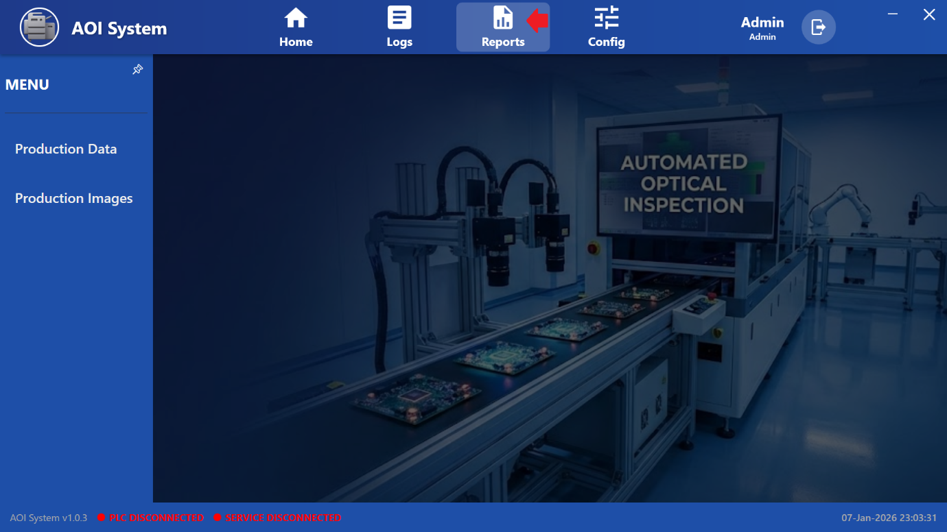

### **30.3 Purpose of the Screen**

The Production Images screen is used to view inspection images captured during production.  
It helps the Operator and Quality team review visual inspection results and verify defects or OK parts.

This screen is used only for viewing stored images.

### 

### **30.4 Screen Overview**

The Production Images screen is divided into two main sections:

1. **Image Folder Panel (Left Side)**
2. **Image Display Area (Right Side)**

The Operator must select a folder to view images stored in that folder.

### **30.5 Image Folder Panel**

The left panel shows a list of available image folders.

#### ***30.5.1 Search Box***

• Used to search image folders by name.  
• Helps quickly locate specific production batches or dates.

#### ***30.5.2 Refresh Button***

• Reloads the list of image folders from storage.  
• Used when new image folders are created during production.

#### ***30.5.3 Folder List***

• Displays folders containing captured inspection images.  
• Each folder usually represents a batch, job, or time-based group of images.

**Operator Action:**  
Click on a folder to load and view images from that folder.

### **30.6 Image Display Area**

• Displays images from the selected folder.  
• If no folder is selected, the message **“Select a Folder”** is shown.  
• Images are displayed in preview format for quick visual inspection.

The Operator can scroll to view multiple images if available.

### **30.7 Operator Actions**

From the Production Images screen, the Operator can:  
• Search image folders  
• Refresh folder list  
• Select folder to view images  
• Review inspection images visually

No image deletion or modification is allowed.

### **30.8 Operator Limitations**

• Operator cannot delete images or folders.  
• Operator cannot download or modify images.  
• Image storage settings are controlled by Admin.

### **30.9 Important Notes for Operator**

• Images are stored automatically during inspection.  
• If no folders appear, verify that inspection has been performed.  
• Use images only for quality verification and traceability.  
• If images are missing, inform maintenance or system administrator.

**31 Config (Configuration) Screen**

### **31.1 Screen Name**

Config (Configuration)

### **31.2 Navigation Path**

Top Menu → Config

When the Operator clicks on **Config** from the top navigation bar, the Configuration screen opens and a left-side menu with configuration options is displayed.

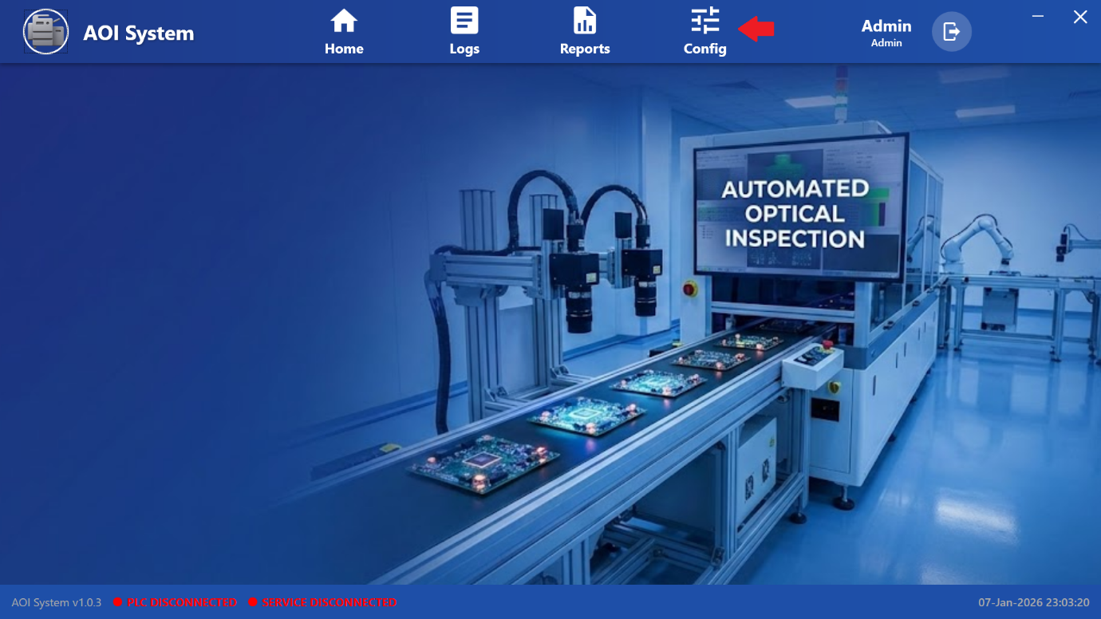

### **31.3 Purpose of the Screen**

The Config screen is used to access and manage system configuration modules required for proper operation of the AOI system.  
It allows authorized users to view and modify configuration related to logging, devices, alarms, users, PLC tags, reports, and diagnostics.

**Operator Note:**  
Configuration settings directly affect system behavior. Changes must be done carefully and only by authorized personnel.

### **31.4 Screen Overview**

The Config screen is divided into two main sections:

1. **Left Side Menu Panel**  
   Displays all available configuration categories.
2. **Main Display Area**  
   Displays the selected configuration screen when a menu option is clicked.

The background area remains inactive until a specific configuration option is selected.

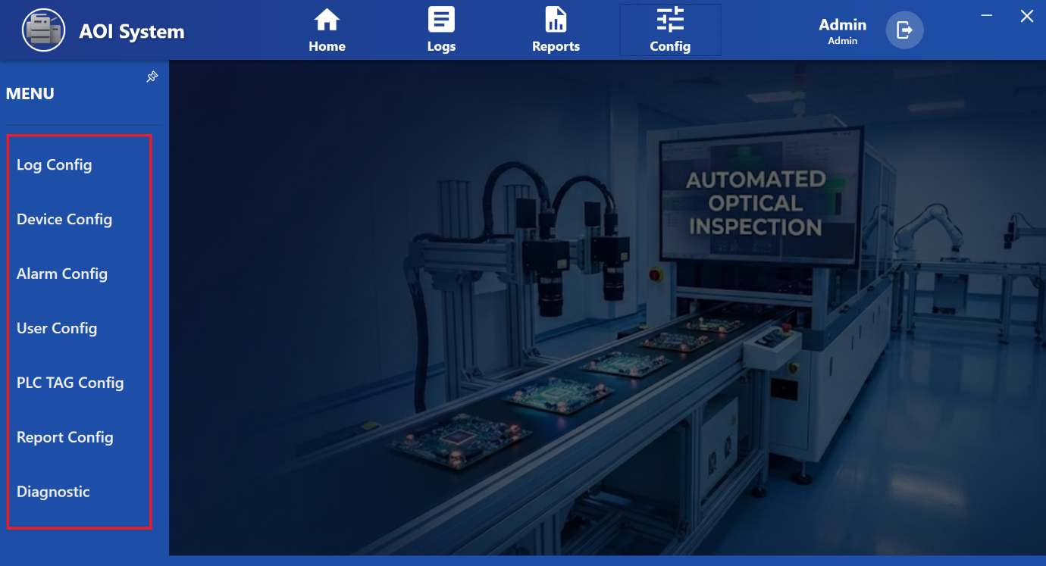

### **31.5 Configuration Menu Options**

The following configuration options are available in the left-side menu:

• Log Config  
• Device Config  
• Alarm Config  
• User Config  
• PLC TAG Config  
• Report Config  
• Diagnostic

Each option opens a dedicated configuration screen in the main display area.

### **31.6 Log Config**

**Purpose:**  
Used to configure system logging behavior.

**Typical Use:**  
• Enable or disable specific log categories  
• Configure log storage or retention (as permitted)

**Operator Guideline:**  
Log settings should be changed only when instructed by system administrator.

### **31.7 Device Config**

**Purpose:**  
Used to configure connected hardware devices such as cameras, sensors, and other peripherals.

**Typical Use:**  
• Verify device connectivity  
• Configure device parameters (if permitted)

**Operator Guideline:**  
Incorrect device configuration may stop inspection or cause incorrect results.

### **31.8 Alarm Config**

**Purpose:**  
Used to manage system alarms and alert conditions.

**Typical Use:**  
• View configured alarm conditions  
• Enable or disable alarms (if permitted)  
• Adjust alarm thresholds as per system requirement

**Operator Guideline:**  
Alarm configuration should not be changed during production.

### **31.9 User Config**

**Purpose:**  
Used to manage system users and access permissions.

**Typical Use:**  
• View user accounts  
• Change passwords (if allowed)  
• Assign user roles as defined by company policy

**Operator Guideline:**  
User role changes must follow company authorization procedures.

### **31.10 PLC TAG Config**

**Purpose:**  
Used to configure PLC communication tags used for data exchange between IPC and PLC.

**Typical Use:**  
• Verify PLC tag mapping  
• Check signal configuration during troubleshooting

**Important:**  
PLC tag configuration must be handled only by trained engineers.

### **31.11 Report Config**

**Purpose:**  
Used to configure report formats and data fields for Reports screen.

**Typical Use:**  
• Create or modify report templates  
• Select which data fields appear in reports

**Operator Guideline:**  
Report configuration affects report generation and export.

### **31.12 Diagnostic**

**Purpose:**  
Used to access system diagnostic and technical health information.

**Typical Use:**  
• View hardware and communication status  
• Collect diagnostic information for troubleshooting

**Operator Guideline:**  
Diagnostic data should be shared with maintenance or technical support when required.

### **31.13 Operator Notes and Precautions**

• Only authorized users should access configuration screens.  
• Do not change any settings unless instructed by supervisor or maintenance team.  
• Incorrect configuration may cause system malfunction or production loss.  
• Always verify machine operation after configuration changes.  
• If unsure, do not proceed and inform administrator.

**32 Log Configuration Screen**

### **32.1 Screen Name**

List Log Configuration

### **32.2 Navigation Path**

Top Menu → Config → Log Config

When the Operator clicks on **Config** from the top menu and then selects **Log Config** from the left-side menu, the **List Log Configuration** screen is displayed.

### **32.3 Purpose of the Screen**

The Log Configuration screen is used to view and manage different categories of system logs generated by the AOI system.  
These logs are required for monitoring system activity, analyzing production, identifying errors, and performing diagnostics.

Logs help in:  
• System monitoring  
• Troubleshooting  
• Audit and compliance  
• Performance analysis

## 32.2 Accessing Log Configuration

1. Click on **Config** from the top navigation bar.
2. From the left-side menu, select **Log Config**.
3. The **List Log Configuration** screen is displayed.

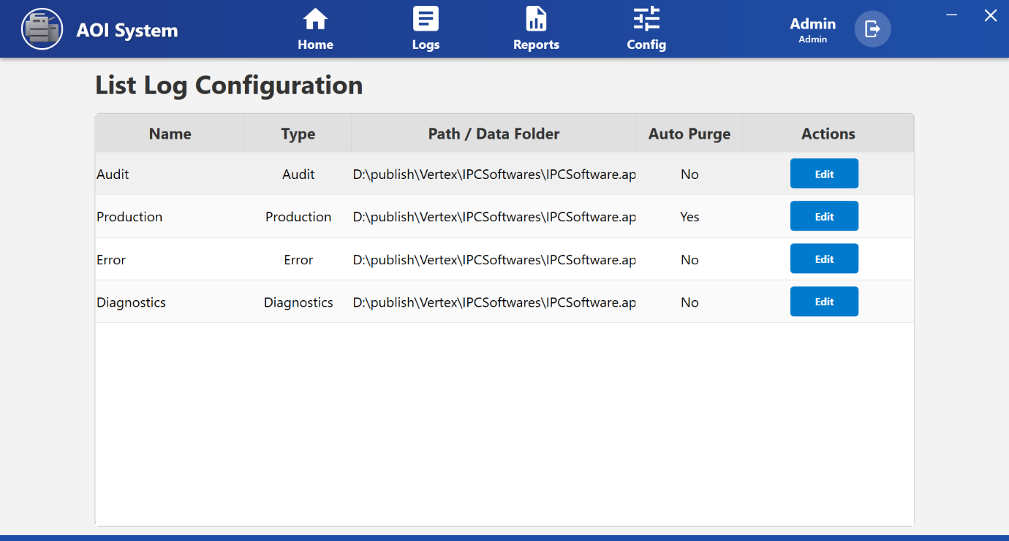

### **32.4 Screen Overview**

The screen displays a list of available log categories in a table format.  
Each row represents one type of system log along with its configuration details and edit option.

The Operator can view:  
• Log name and type  
• Storage location of log files  
• Auto purge status  
• Option to edit configuration

### **32.5 Table Columns Description**

The following columns are displayed on the screen:

• **Name** – Displays the log category name (Audit, Production, Error, Diagnostics)  
• **Type** – Shows the log type corresponding to the category  
• **Path / Data Folder** – Displays the file storage path where logs are saved  
• **Auto Purge** – Indicates whether automatic deletion of old logs is enabled (Yes/No)  
• **Actions** – Provides an **Edit** button to modify configuration

### **32.6 Operator Actions**

#### ***32.6.1 Edit Log Configuration***

To edit log settings:

1. Click the **Edit** button for the required log.
2. Modify allowed configuration fields such as:  
   • Storage path  
   • Auto purge option (if permitted)
3. Save the updated settings.

Changes should be made only if the Operator is authorized.

### **32.7 Operator Limitations**

• Operators cannot add or delete log categories.  
• Log generation is automatic and cannot be disabled.  
• Some configuration fields may be restricted based on user role.  
• Advanced settings are accessible only to Admin users.

### **32.8 Important Notes for Operator**

• Log configuration affects how long data is stored in the system.  
• Incorrect path settings may cause log loss.  
• Always confirm with supervisor before changing any log settings.  
• Ensure sufficient disk space is available for log storage.  
• If logs are not updating, report to maintenance or administrator.

**33 Device Configuration Screen**

## 33.1 Screen Overview

The **Device Configuration Screen** allows the operator to view and manage hardware devices connected to the AOI system, such as PLCs and other control devices.  
This screen provides visibility into device details including type, make, model, and configuration status.

Device configuration ensures correct communication between the AOI software and connected hardware.

**Operator Note:**  
Device configuration should be handled carefully, as incorrect settings may affect machine operation.

## 33.2 Accessing Device Configuration

1. Click on **Config** from the top navigation bar.
2. From the left-side menu, select **Device Config**.
3. The **Device Configuration** screen is displayed.

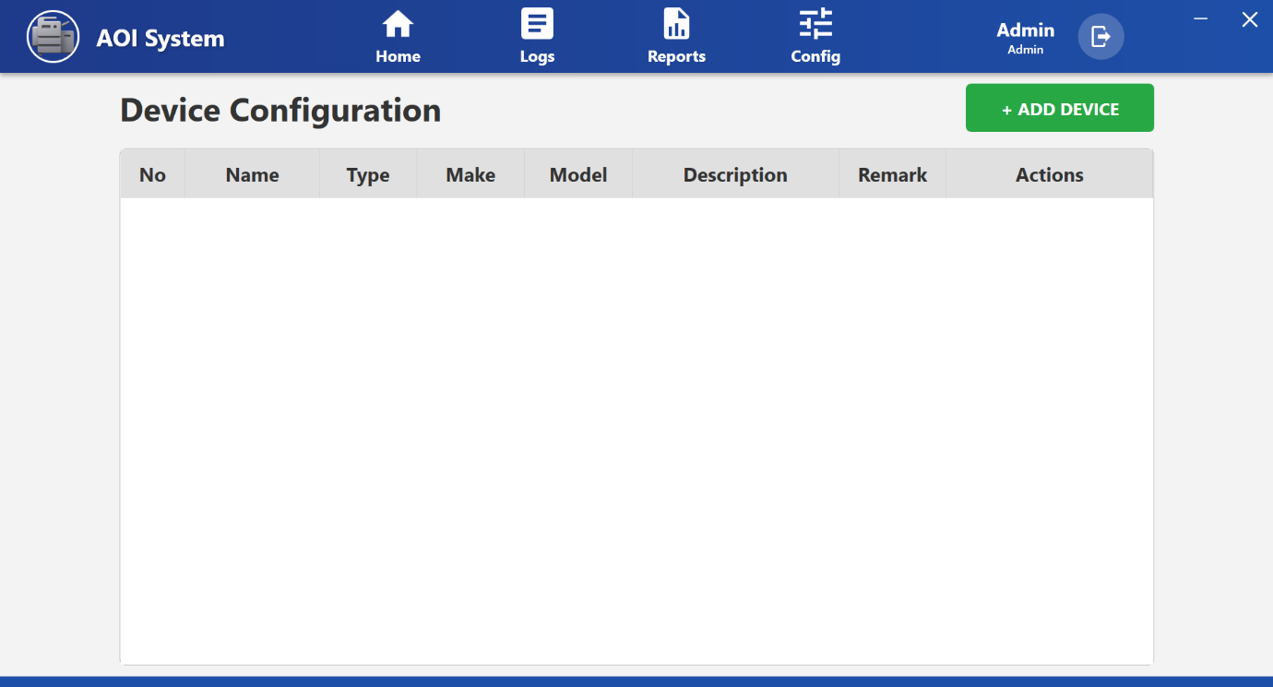

## 33.3 Screen Layout Description

The Device Configuration screen displays a list of configured devices in a table format along with action buttons.

### **Table Columns**

* **No** – Serial number of the device
* **Name** – Device name (e.g., PLC1)
* **Type** – Type of device (e.g., PLC)
* **Make** – Manufacturer of the device
* **Model** – Device model number
* **Description** – Additional device information
* **Remark** – Operator or system remarks
* **Actions** – Available actions for the device

## 33.4 Available Operator Actions

### **Add Device**

* Click **+ ADD DEVICE** to add a new device to the system.
* This option is generally used during initial setup or hardware replacement.

This action is typically restricted to authorized users.

### **Config**

* Click **Config** to configure communication parameters for the selected device.
* Used to set device-specific settings required for system communication.

### **Edit**

* Click **Edit** to modify device details such as name, description, or remarks.
* Use this option only when changes are required.

### **Delete**

* Click **Delete** to remove the selected device from the system.
* This action should be performed only if the device is no longer in use.
* Deleting an active device may cause system communication failure.

## 33.5 Operator Notes And Precautions

* Ensure the correct device is selected before performing any action.
* Do not modify PLC or device parameters without proper authorization.
* Verify device connection status after configuration changes.
* If PLC connection shows disconnected, inform maintenance personnel.

**34 Alarm Configuration Screen**

## 34.1 Screen Overview

The **Alarm Configuration Screen** allows the operator to view and manage all system alarms used in the AOI system.  
Alarms are generated when abnormal conditions, faults, or communication issues occur during machine operation.

This screen provides visibility into alarm details such as severity, PLC tag mapping, and alarm messages displayed to the operator.

**Operator Note:**  
Alarm configuration directly affects how faults are detected and displayed. Changes should be made only by authorized personnel.

## 34.2 Accessing Alarm Configuration

1. Click on **Config** from the top navigation bar.
2. From the left-side menu, select **Alarm Config**.
3. The **Alarm Configuration** screen is displayed with a list of configured alarms.

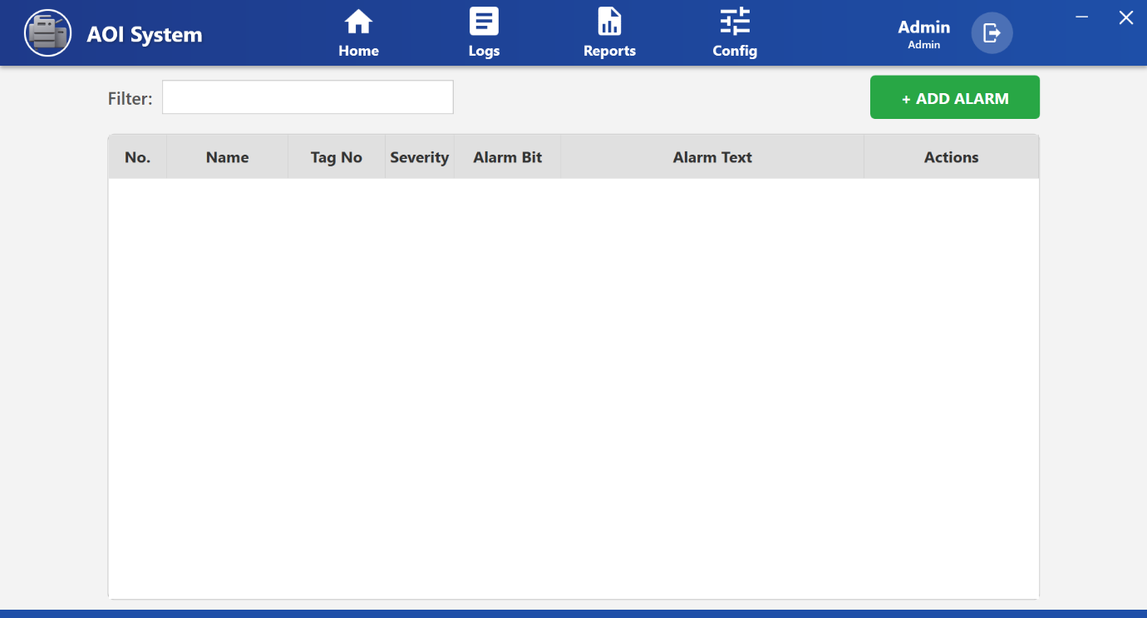

## 34.3 Screen Layout Description

The Alarm Configuration screen displays alarms in a tabular format along with control options.

### **Top Controls**

* **Filter** – Used to search alarms by name or keyword.
* **+ ADD ALARM** – Used to add a new alarm to the system (restricted access).

## 34.4 Alarm List Table Description

Each alarm entry contains the following information:

* **No.** – Serial number of the alarm
* **Name** – Alarm name displayed in the system
* **Tag No** – PLC tag number associated with the alarm
* **Severity** – Alarm priority level (e.g., High)
* **Alarm Bit** – PLC bit position used for alarm detection
* **Alarm Text** – Detailed message shown to the operator
* **Actions** – Options to edit or delete the alarm

## 34.5 Typical Alarm Examples (Operator View)

* **Abnormal startup condition** – Indicates incorrect startup sequence
* **IPC communication abnormalities** – IPC communication failure
* **Pressure drop alarm** – Air or pressure-related issue
* **SV alarm anomaly** – Solenoid valve malfunction
* **CCD controller abnormality** – Vision system controller fault
* **STAMP alarm abnormality** – Process or station-specific issue

These alarms help the operator quickly identify the source of the problem.

## 34.6 Operator Actions

### **View Alarm Details**

* Operators can view alarm names, severity, and alarm text for understanding the issue.

### **Edit Alarm**

* Click **Edit** to modify alarm details such as text or mapping.
* Typically performed by maintenance or admin users.

### **Delete Alarm**

* Click **Del** to remove an alarm from the system.
* This action should be avoided unless instructed.
* Removing alarms may result in missing fault indications.

## 34.7 Operator Notes And Precautions

* Do not modify alarm severity or PLC mapping without approval.
* Always read the **Alarm Text** carefully before taking corrective action.
* If repeated alarms occur, inform maintenance personnel.
* Ensure alarms are not disabled unintentionally.

**35 User Config**

## 35.1 Screen Overview

The **User Management Screen (User Config)** allows authorized personnel to view and manage users who can access the AOI system.  
This screen controls **user accounts, roles, and active status**, ensuring that only permitted users can operate or configure the system.

User management helps maintain **system security, accountability, and controlled access**.

**Operator Note:**  
User configuration affects system access. Any changes should be done only with proper authorization.

## 35.2 Accessing User Management

1. Click on **Config** from the top navigation bar.
2. From the left-side menu, select **User Config**.
3. The **User Management** screen is displayed.

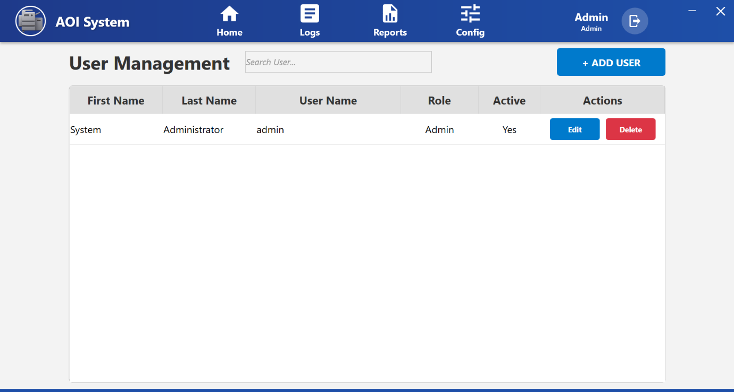

## 35.3 Screen Layout Description

The User Management screen consists of:

### **Top Controls**

* **Search User** – Used to search users by name or username.
* **+ ADD USER** – Used to create a new user account (restricted access).

### **User List Table**

Displays all configured users with their details and action buttons.

## 35.4 User List Table Description

Each user entry contains the following information:

* **First Name** – User’s first name
* **Last Name** – User’s last name
* **User Name** – Login username
* **Role** – Access level assigned to the user
  + Admin – Full system access
  + User – Limited operational access
* **Active** – Indicates whether the user account is enabled
* **Actions** – Options to edit or delete the user

## 35.5 Operator Actions

### **View Users**

* Operators can view the list of users and their assigned roles.
* Helps identify who has access to the system.

### **Add User**

* Click **+ ADD USER** to create a new user.
* Used when a new operator or admin needs system access.

This action is typically restricted to Admin users.

### **Edit User**

* Click **Edit** to modify user details such as name, role, or active status.
* Commonly used for role changes or updating user information.

### **Delete User**

* Click **Delete** to remove a user from the system.
* Used when a user no longer requires access.

Deleting an active or required user may restrict system operation.

## 35.6 Operator Notes And Precautions

* Do not share login credentials with others.
* Ensure each operator has a unique user account.
* Assign roles carefully based on job responsibility.
* Disable or delete users who no longer require access.
* Any unexpected login or access issue should be reported immediately.

**36 PLC Tag Configuration Screen**

## 36.1 Screen Overview

The **PLC Tag Configuration Screen** allows authorized users to view and manage PLC tags used for communication between the AOI software and the PLC.  
PLC tags define how data is read from or written to the PLC, including addresses, data length, and scaling logic.

This screen plays a critical role in **machine control, data acquisition, and alarm handling**.

**Operator Note:**  
PLC tag configuration directly affects machine behavior. Any incorrect change may cause communication failure or incorrect operation.

## 36.2 Accessing PLC Tag Configuration

1. Click on **Config** from the top navigation bar.
2. From the left-side menu, select **PLC TAG Config**.
3. The **PLC Tag Configuration** screen is displayed.

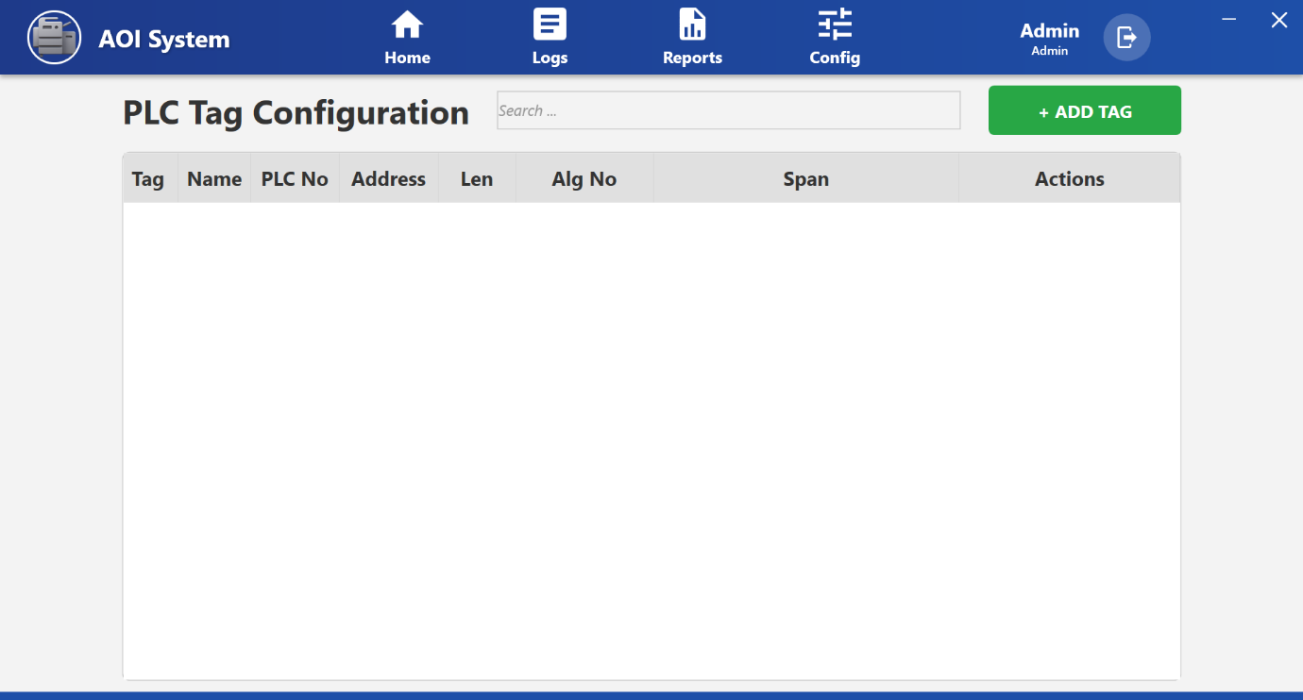

## 36.3 Screen Layout Description

The PLC Tag Configuration screen displays a list of configured PLC tags in a tabular format.

### **Top Controls**

* **Search** – Used to search PLC tags by name.
* **+ ADD TAG** – Used to add a new PLC tag (restricted access).

## 36.4 PLC Tag Table Description

Each PLC tag entry contains the following details:

* **Tag** – Serial number of the PLC tag
* **Name** – PLC tag name used by the system
* **PLC No** – PLC number to which the tag belongs
* **Address** – PLC memory address
* **Len** – Data length of the tag
* **Alg No** – Algorithm or scaling logic applied
  + Example: Linear scale, Unknown
* **Span** – Scaling or range value (if applicable)
* **Actions** – Options to edit or delete the PLC tag

## 36.5 Typical PLC Tag Usage (Operator View)

* **Communication Tags** – Used for handshake and status signals between IPC and PLC
* **System Data Tags** – Used for system states, control bits, and data exchange
* **Alarm Tags** – Used to trigger alarms based on PLC bit status

These tags allow the AOI system to monitor and control machine operation accurately.

**36.6 Operator Actions**

**View PLC Tags**

* Operators can view tag names, addresses, and PLC mapping for reference.
* Useful during troubleshooting with maintenance teams.

### **Add PLC Tag**

* Click **+ ADD TAG** to add a new PLC tag.
* Used during initial system setup or PLC program changes.
* This action should be performed only by trained and authorized personnel.

### **Edit PLC Tag**

* Click **Edit** to modify PLC tag parameters such as address, length, or algorithm.
* Used when PLC logic or addressing changes.

### **Delete PLC Tag**

* Click **Delete** to remove an unused PLC tag.
* Should be done only after confirming the tag is no longer required.
* Deleting an active PLC tag may cause system malfunction.

## 36.7 Operator Notes And Precautions

* Never change PLC addresses without confirmation from PLC program documentation.
* Always verify PLC communication after making tag changes.
* Do not modify algorithm or span values unless instructed.
* If PLC communication errors occur, inform maintenance immediately.
* Keep PLC tag configuration consistent with PLC logic.

# **37 Report Configuration Screen**

### **37.1 Screen Name**

Report Format Configuration

### **37.2 Navigation Path**

Top Menu → Config → Report Config

When the Operator clicks on **Config** from the top menu and then selects **Report Config** from the left-side menu, the **Report Format Configuration** screen is displayed.

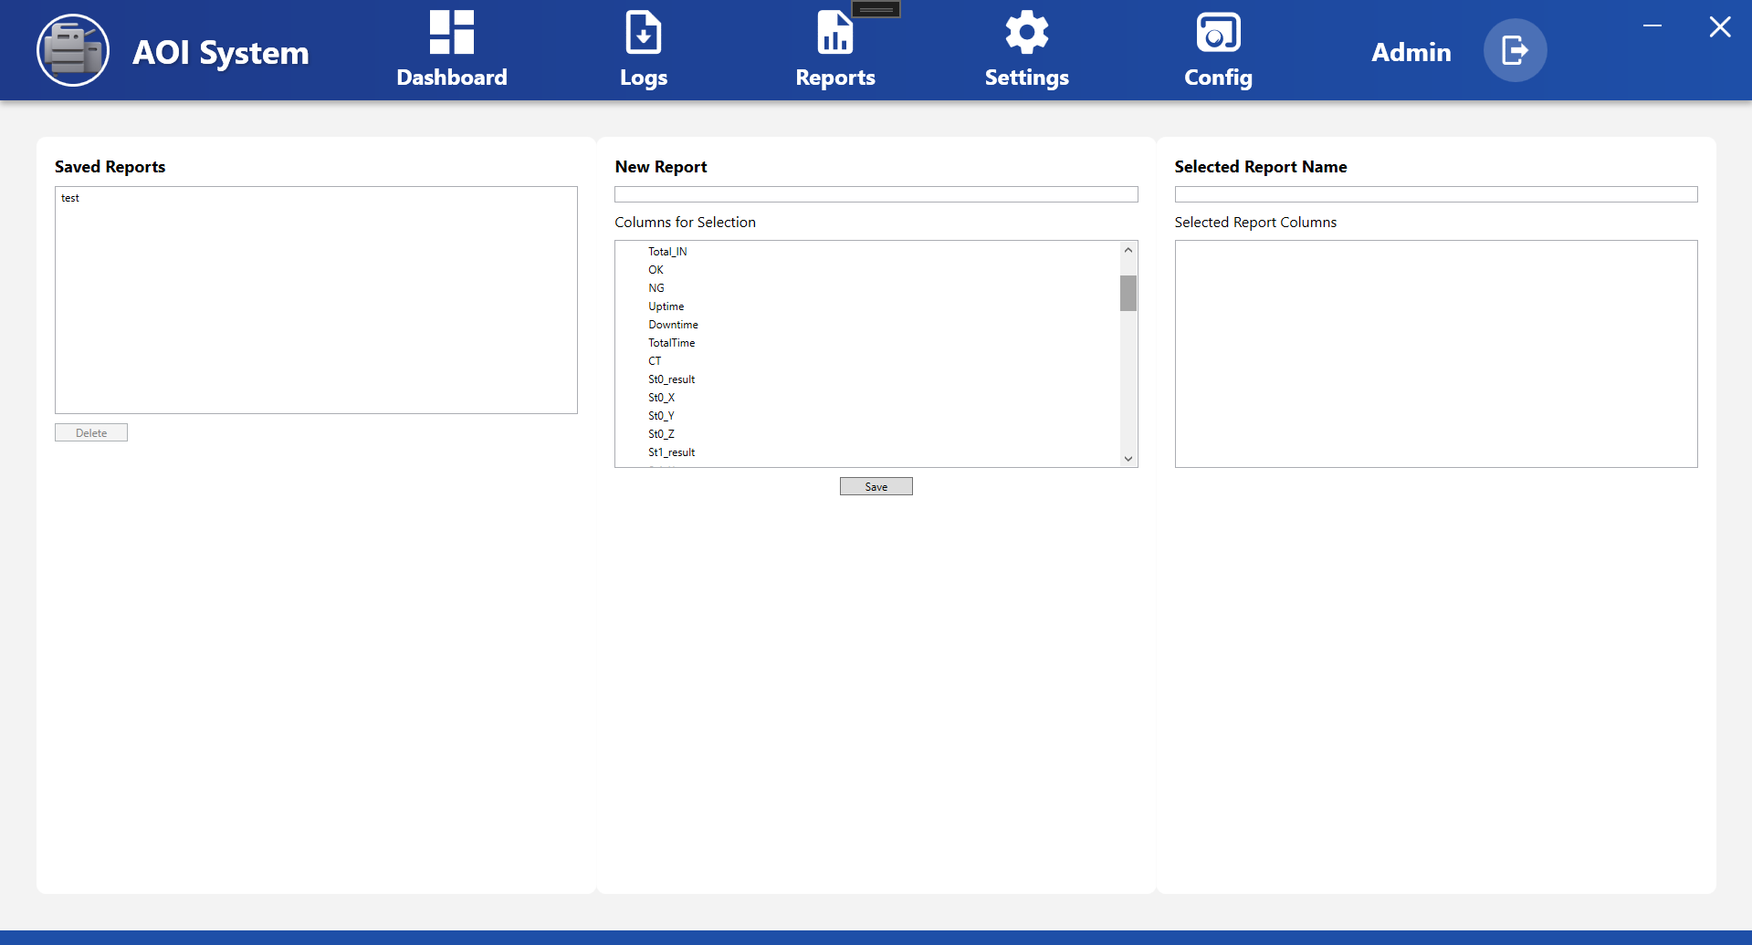

### **37.3 Purpose of the Screen**

The Report Configuration screen is used to create, edit, and manage report formats used in the Reports section.  
This screen allows the Operator or authorized user to select which data columns will be included in generated reports.

Configured report formats are later used in:  
Top Menu → Reports → Report Viewer

This screen is used only for report format setup, not for viewing report data.

### **37.4 Screen Overview**

The screen is divided into three main panels:

1. **Saved Report Formats** (Left Panel)
2. **Report Details** (Middle Panel)
3. **Selected Columns** (Right Panel)

At the bottom of the screen, action buttons are provided to clear selection and save report formats.

### **37.5 Saved Report Formats Panel**

**Purpose:**  
Displays a list of all previously saved report formats.

**Functions:**  
• Shows available report names  
• Allows selecting an existing report format  
• **New** button is used to create a new report format  
• **Delete** button removes the selected report format

**Operator Use:**  
Used to manage existing report formats and create new ones.

### **37.6 Report Details Panel**

**Purpose:**  
Used to define report name and select available data columns.

**Fields and Controls:**  
• **Report Name** – Field to enter or edit report name  
• **Available Columns** – List of all data fields that can be added to the report

Typical available columns may include:  
• Timestamp  
• 2D_Code  
• OEE  
• Availability  
• Performance  
• Quality  
• Total_IN  
• OK  
• NG  
• Other production and inspection parameters

**Operator Use:**  
Select required columns that should appear in the final report.

### **37.7 Selected Columns Panel**

**Purpose:**  
Displays the list of columns that are currently selected for the report format.

**Details Shown:**  
• Report Name  
• Columns included in the report  
• Total number of selected columns

**Operator Use:**  
Used to verify report structure before saving.

### **37.8 Action Buttons**

• **Clear Selection**  
Clears all selected columns from the report format.

• **Save Report Format**  
Saves the current report configuration for future use in Reports screen.

### **37.9 Operator Actions**

#### **37.9.1 Create New Report Format**

1. Click **New** in Saved Report Formats panel.
2. Enter Report Name in Report Details panel.
3. Select required columns from Available Columns list.
4. Verify selected fields in Selected Columns panel.
5. Click **Save Report Format**.

#### **37.9.2 Edit Existing Report Format**

1. Select report from Saved Report Formats list.
2. Modify report name or selected columns if required.
3. Click **Save Report Format** to update.

#### **37.9.3 Delete Report Format**

1. Select report from Saved Report Formats list.
2. Click **Delete**.
3. The selected report format is permanently removed.

Deleted report formats cannot be recovered.

### **37.10 Operator Limitations**

• Operators cannot modify system data sources.  
• Only report structure can be changed.  
• Some configuration options may be restricted to Admin users.  
• Actual report data cannot be edited from this screen.

### **37.11 Important Notes for Operator**

• Use clear and meaningful report names.  
• Select only required columns to avoid unnecessary large reports.  
• Do not delete commonly used reports without confirmation.  
• Report configuration does not affect live machine operation.  
• After saving report format, it will be available in Reports → Report Viewer.

**38 Diagnostic Screen**

### **38.1 Screen Name**

Diagnostic

### **38.2 Navigation Path**

Top Menu → Config → Diagnostic

When the Operator clicks on **Config** from the top menu and then selects **Diagnostic** from the left-side menu, the **Diagnostic** screen is displayed.

### **38.3 Purpose of the Screen**

The Diagnostic screen is used to monitor and test PLC tag values for troubleshooting and system verification.  
It allows authorized users to view current PLC data values and, if permitted, write test values for diagnostic purposes.

This screen is mainly used during:  
• Troubleshooting  
• Maintenance checks  
• System testing

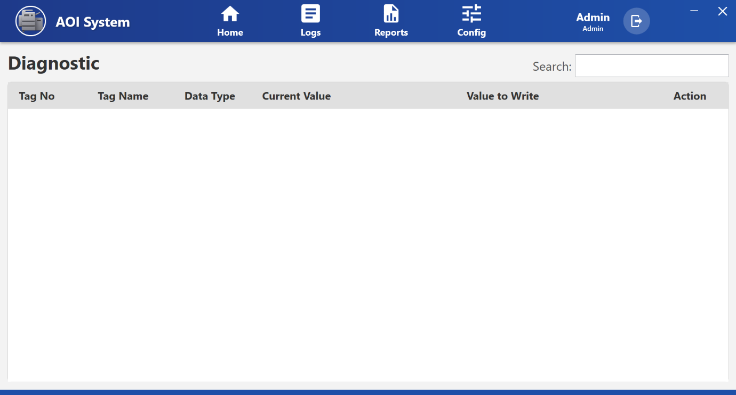

### **38.4 Screen Overview**

The screen displays PLC tag data in a table format.  
A search box is available at the top right to quickly find specific tags.

Each row in the table represents one PLC tag with its current value and an option to write a new value (if enabled).

### **38.5 Table Columns Description**

The following columns are displayed:

• **Tag No** – Unique identification number of the PLC tag  
• **Tag Name** – Name of the PLC signal or variable  
• **Data Type** – Type of data (e.g., Bool, Int, Real, etc.)  
• **Current Value** – Live value currently received from PLC  
• **Value to Write** – Field to enter a test value (if writing is allowed)  
• **Action** – Button to write the entered value to PLC

### **38.6 Search Function**

• The **Search** box allows filtering tags by:  
– Tag number  
– Tag name

• Helps quickly locate specific PLC signals during diagnostics.

### **38.7 Operator Actions**

• Observe the **Current Value** column to verify live PLC data.  
• Used to confirm sensor signals and system states.

### **38.8 Operator Limitations**

• Writing PLC values may be restricted based on user role.  
• Operators should not change PLC values during production.  
• Incorrect values may affect machine operation.

### **38.9 Important Notes for Operator**

• Use this screen only when machine is in safe condition.  
• Do not modify PLC values without proper instruction.  
• Always restore values after testing.  
• If abnormal signals are observed, report to maintenance team.  
• This screen is for diagnostic purpose only, not for normal operation.